Lecture 6:

Training Neural Networks,

Part 2



Fei-Fei Li & Andrej Karpathy & Justin Johnson Lecture 6 1 25 Jan 2016

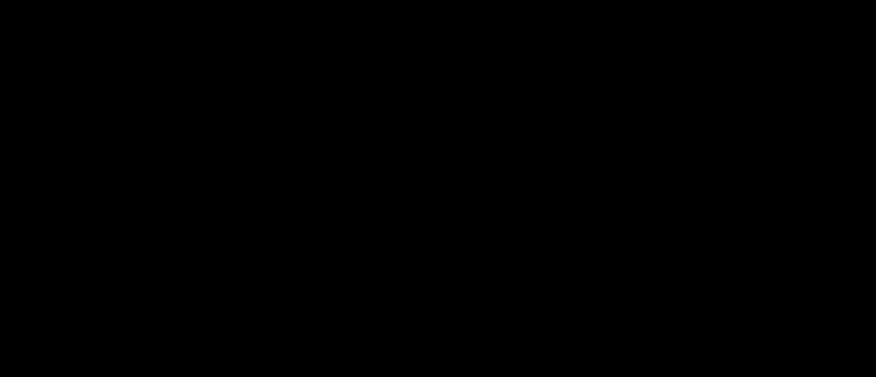Administrative

A2 is out. It’s meaty. It’s due Feb 5 (next Friday)

You’ll implement:

Neural Nets (with Layer Forward/Backward API)

Batch Norm

Dropout

ConvNets



Fei-Fei Li & Andrej Karpathy & Justin Johnson Lecture 6 2 25 Jan 2016

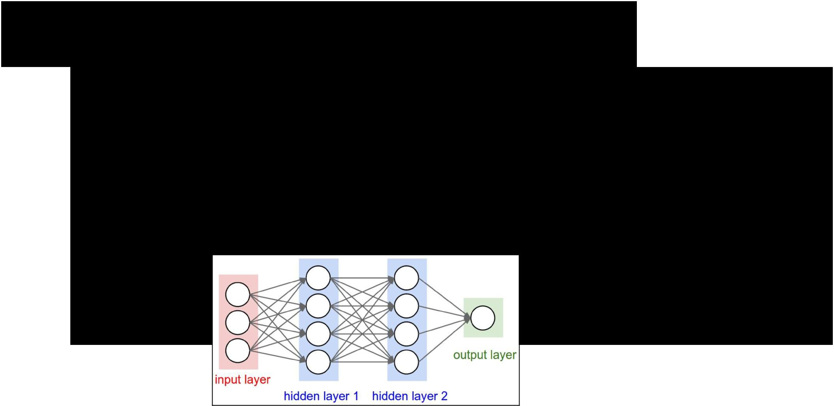**Mini-batch SGD**

Loop:

1. **Sample** a batch of data
2. **Forward** prop it through the graph, get loss
3. **Backprop** to calculate the gradients
4. **Update** the parameters using the gradient



Fei-Fei Li & Andrej Karpathy & Justin Johnson Lecture 6 3 25 Jan 2016

|  |  |  |
| --- | --- | --- |
| Activation Functions | **Leaky ReLU** |  |
| max(0.1x, x) |  |
| **Sigmoid** |  |  |

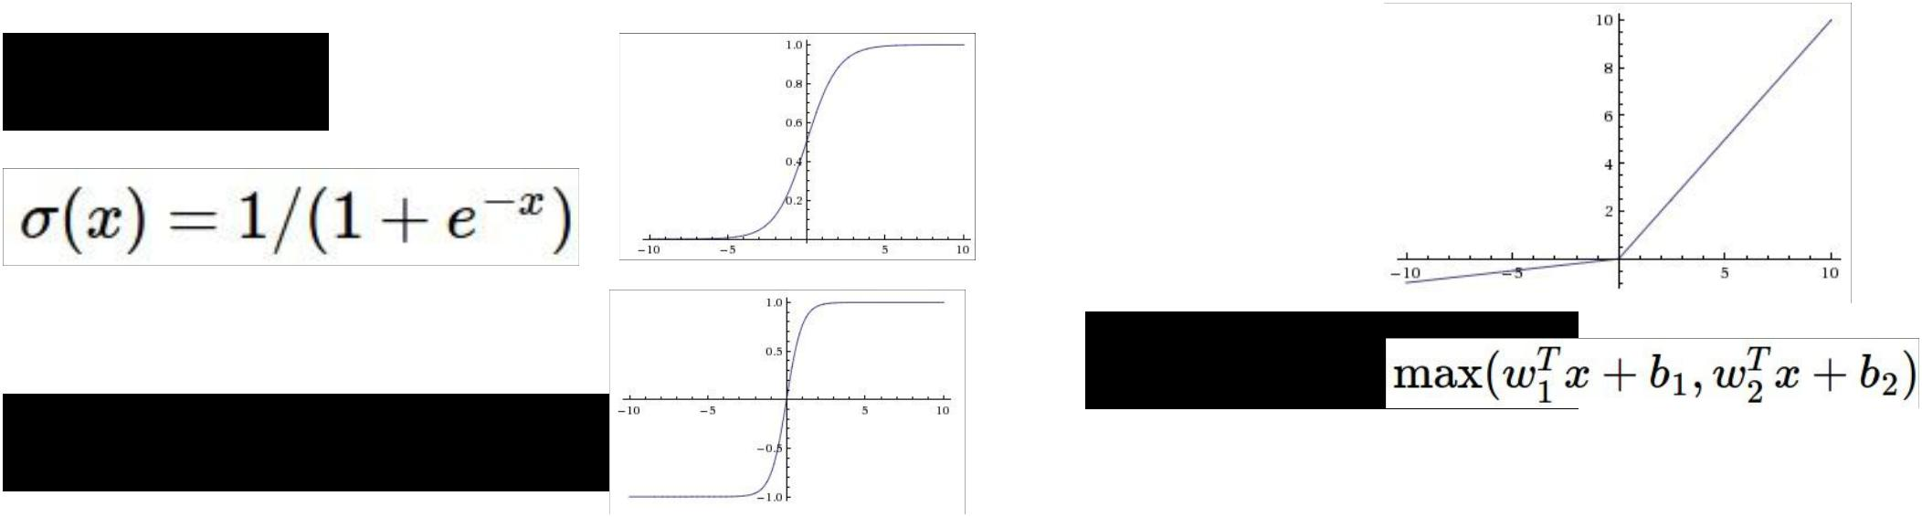

**Maxout**

**tanh** tanh(x)

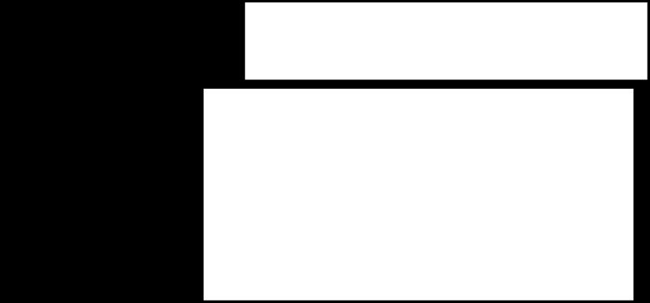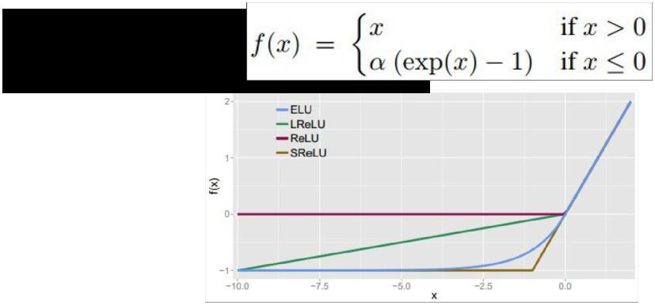

**ELU**

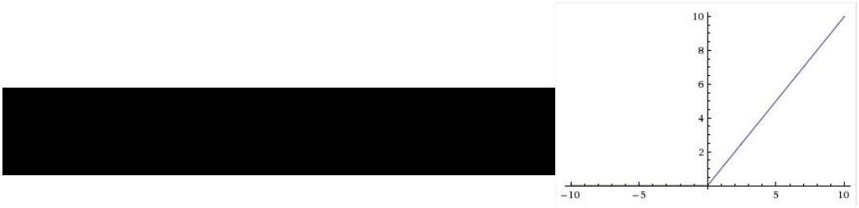

**ReLU** max(0,x)



Fei-Fei Li & Andrej Karpathy & Justin Johnson Lecture 6 4 25 Jan 2016

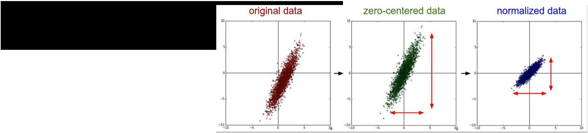Data

Preprocessing

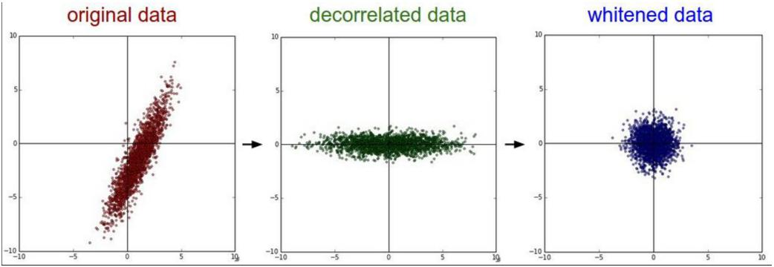

Fei-Fei Li & Andrej Karpathy & Justin Johnson Lecture 6 5 25 Jan 2016

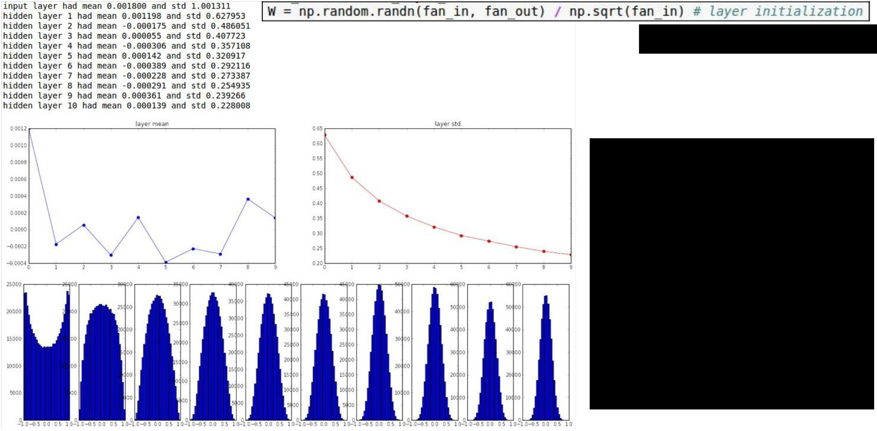“Xavier initialization” [Glorot et al., 2010]

**Reasonable initialization.** (Mathematical derivation assumes linear activations)

Weight Initialization



Fei-Fei Li & Andrej Karpathy & Justin Johnson Lecture 6 6 25 Jan 2016

Batch Normalization

Normalize:

And then allow the network to squash the range if it wants to:

[Ioffe and Szegedy, 2015]

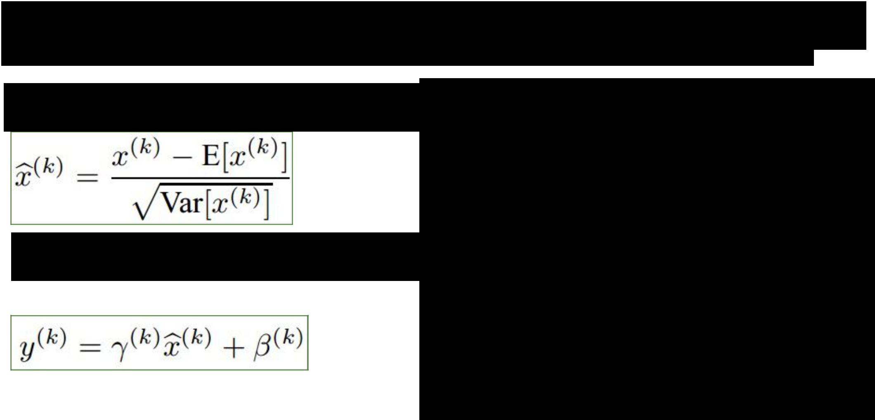

* Improves gradient flow through the network
* Allows higher learning rates
* Reduces the strong dependence on initialization
* Acts as a form of regularization in a funny way, and slightly reduces the need for dropout, maybe



Fei-Fei Li & Andrej Karpathy & Justin Johnson Lecture 6 7 25 Jan 2016

|  |  |  |  |  |  |  |  |
| --- | --- | --- | --- | --- | --- | --- | --- |
| Babysitting the | | | | | | | Cross-validation |
| learning process | | | | | | |  |
|  |  |  |  |  |  |  |  |
|  |  |  |  |  |  |  |  |
|  |  |  |  |  |  |  |  |
|  |  |  |  |  |  |  |  |

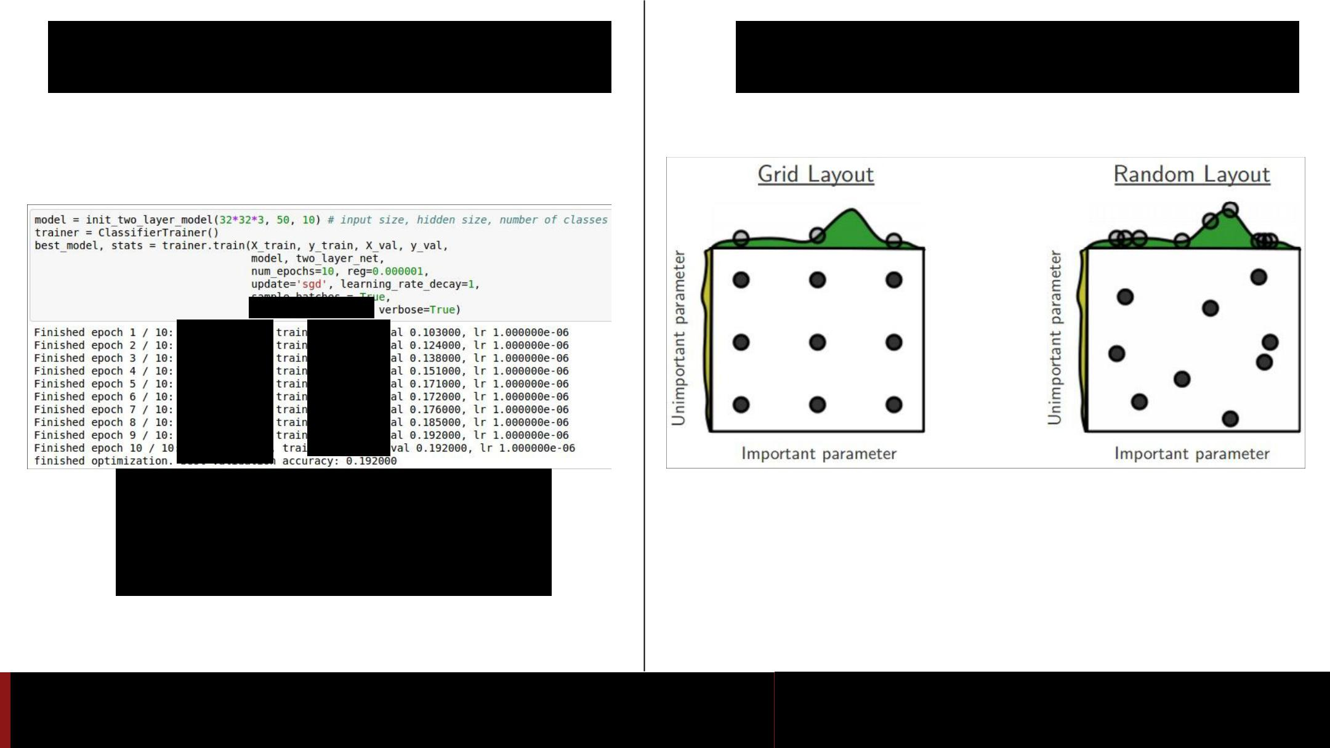

Loss barely changing:

Learning rate is probably

too low

Fei-Fei Li & Andrej Karpathy & Justin Johnson Lecture 6 8 25 Jan 2016

TODO

* Parameter update schemes
* Learning rate schedules
* Dropout
* Gradient checking
* Model ensembles



Fei-Fei Li & Andrej Karpathy & Justin Johnson Lecture 6 9 25 Jan 2016



Parameter Updates



Fei-Fei Li & Andrej Karpathy & Justin Johnson Lecture 6 10 25 Jan 2016

Training a neural network, main loop:

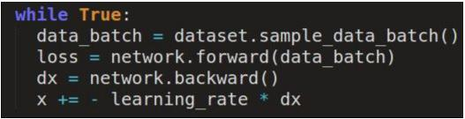

Fei-Fei Li & Andrej Karpathy & Justin Johnson Lecture 6 11 25 Jan 2016

Training a neural network, main loop:

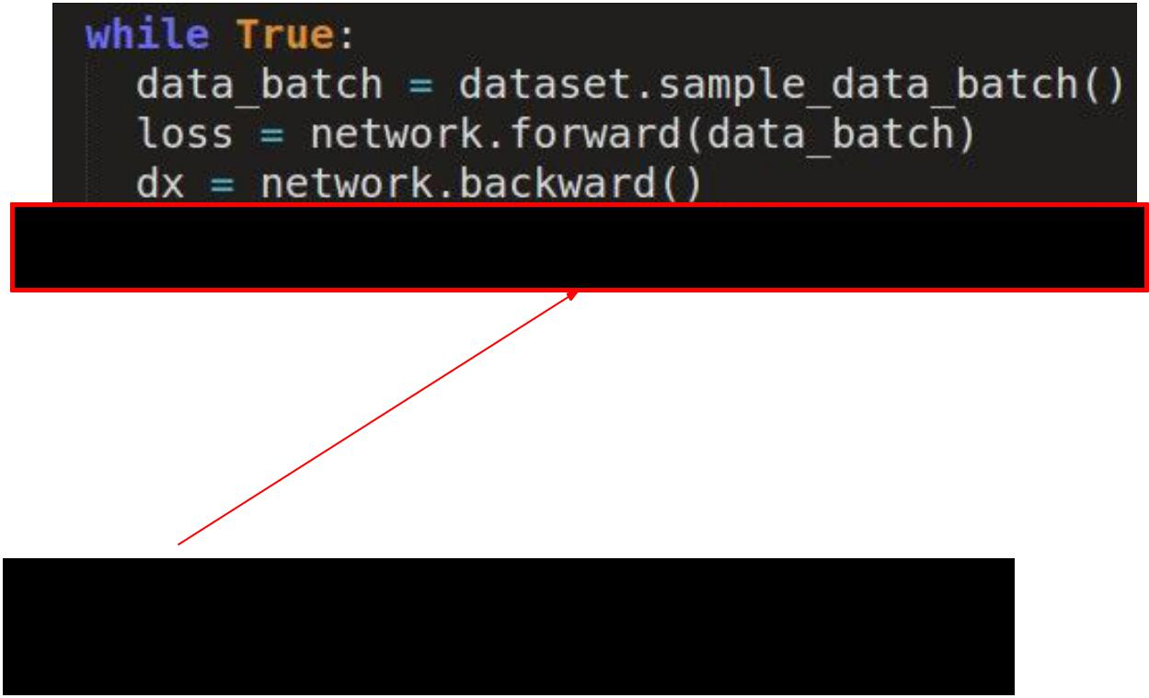

simple gradient descent update

now: complicate.



Fei-Fei Li & Andrej Karpathy & Justin Johnson Lecture 6 12 25 Jan 2016

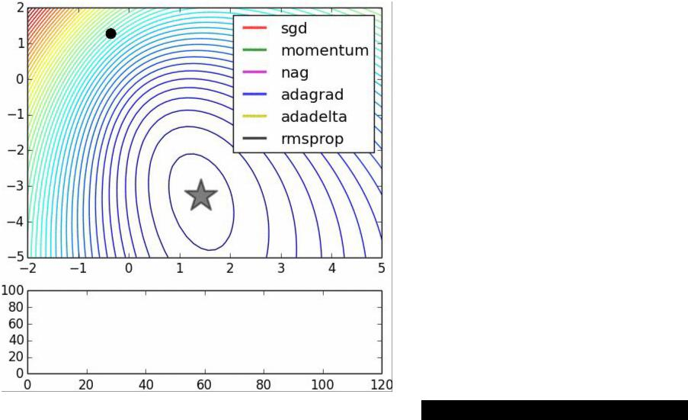

Image credits: Alec Radford



Fei-Fei Li & Andrej Karpathy & Justin Johnson Lecture 6 13 25 Jan 2016

Suppose loss function is steep vertically but shallow horizontally:



1. What is the trajectory along which we converge towards the minimum with SGD?



Fei-Fei Li & Andrej Karpathy & Justin Johnson Lecture 6 14 25 Jan 2016

Suppose loss function is steep vertically but shallow horizontally:



1. What is the trajectory along which we converge towards the minimum with SGD?



Fei-Fei Li & Andrej Karpathy & Justin Johnson Lecture 6 15 25 Jan 2016

Suppose loss function is steep vertically but shallow horizontally:



1. What is the trajectory along which we converge towards the minimum with SGD? very slow progress along flat direction, jitter along steep one



Fei-Fei Li & Andrej Karpathy & Justin Johnson Lecture 6 16 25 Jan 2016

Momentum update

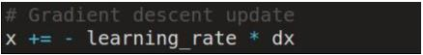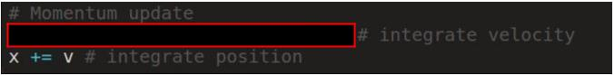

* Physical interpretation as ball rolling down the loss function + friction (mu coefficient).
* mu = usually ~0.5, 0.9, or 0.99 (Sometimes annealed over time, e.g. from 0.5 -> 0.99)



Fei-Fei Li & Andrej Karpathy & Justin Johnson Lecture 6 17 25 Jan 2016

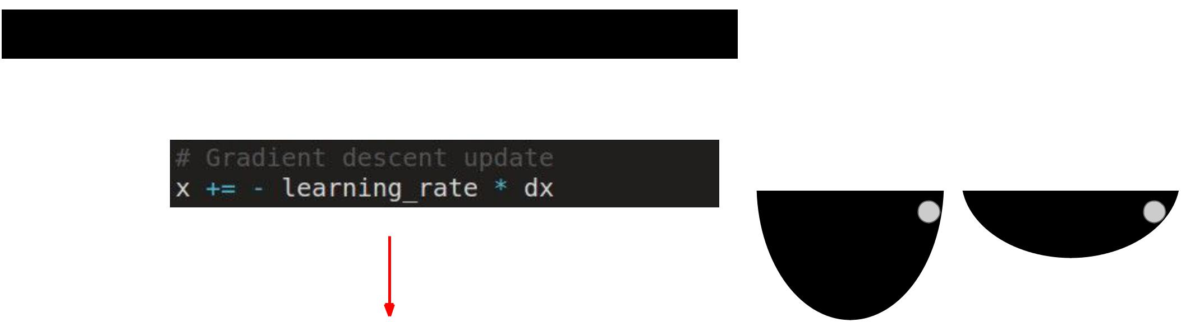Momentum update

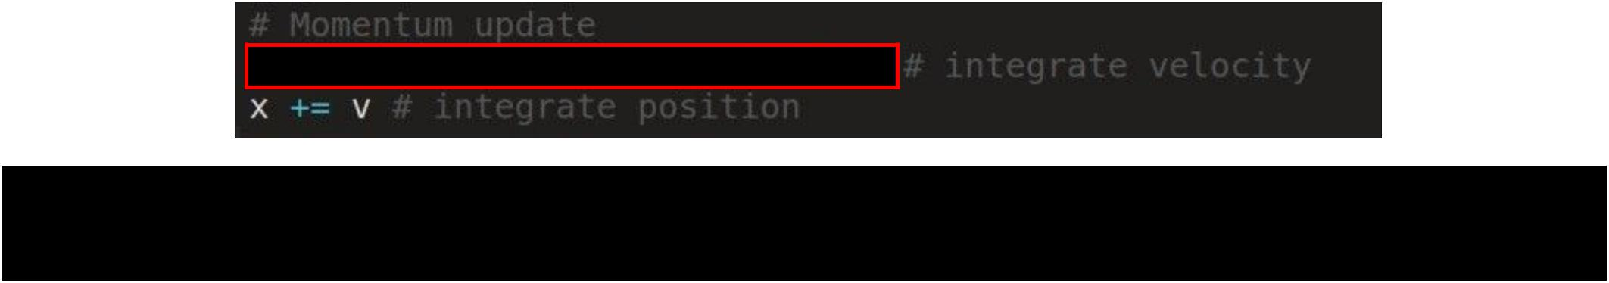

* Allows a velocity to “build up” along shallow directions
* Velocity becomes damped in steep direction due to quickly changing sign



Fei-Fei Li & Andrej Karpathy & Justin Johnson Lecture 6 18 25 Jan 2016

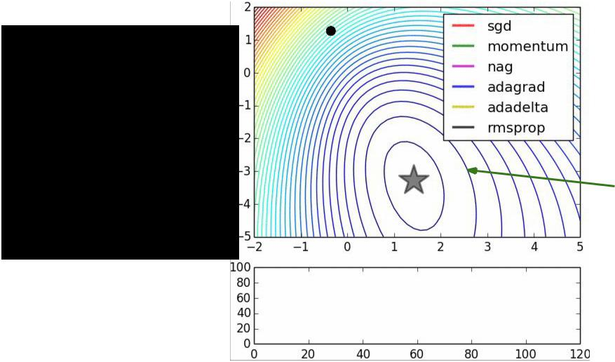SGD

vs

Momentum

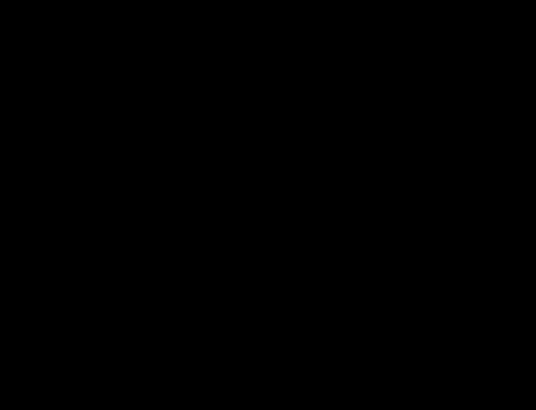

notice momentum overshooting the target, but overall getting to the minimum much faster.



Fei-Fei Li & Andrej Karpathy & Justin Johnson Lecture 6 19 25 Jan 2016

Nesterov Momentum update

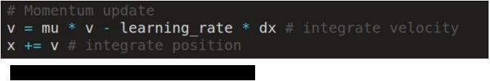

Ordinary momentum update:

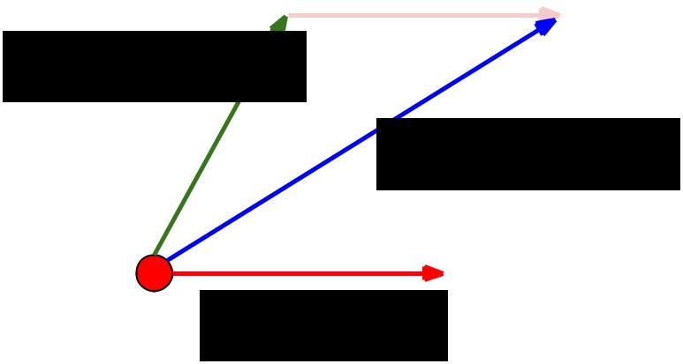

momentum

step

actual step



gradient

step



Fei-Fei Li & Andrej Karpathy & Justin Johnson Lecture 6 20 25 Jan 2016

Nesterov Momentum update

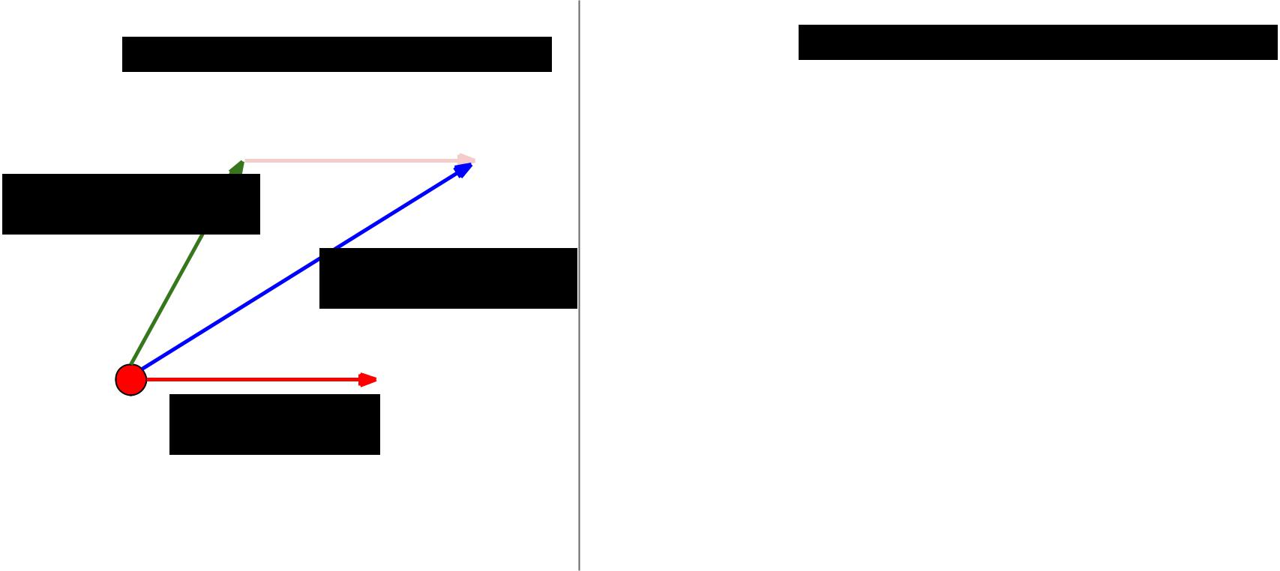

Momentum update



momentum

step

actual step



gradient

step

Nesterov momentum update

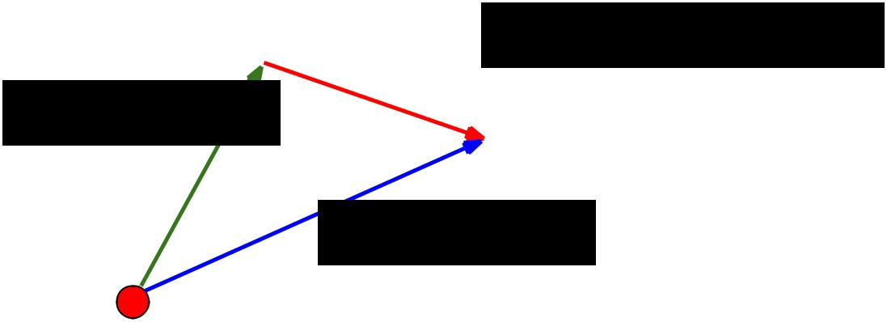

|  |  |  |
| --- | --- | --- |
|  | “lookahead” gradient |  |
| momentum | step (bit different than |  |
| original) |  |
| step |  |  |
|  | actual step |  |



Fei-Fei Li & Andrej Karpathy & Justin Johnson Lecture 6 21 25 Jan 2016

Nesterov Momentum update

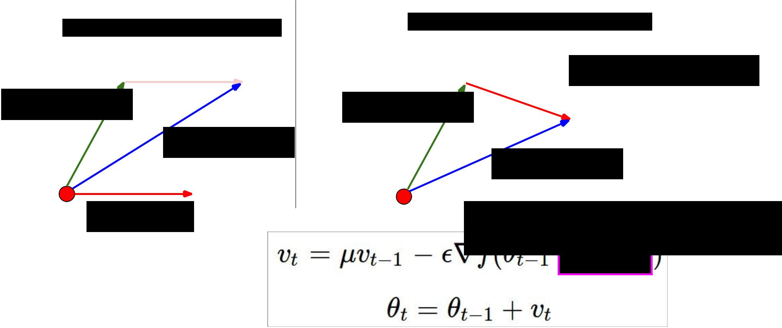

Momentum update



momentum

step

actual step



gradient

step

Nesterov momentum update

|  |  |  |
| --- | --- | --- |
|  | “lookahead” gradient |  |
| momentum | step (bit different than |  |
| original) |  |
| step |  |  |
|  | actual step |  |

Nesterov: the only difference...



Fei-Fei Li & Andrej Karpathy & Justin Johnson Lecture 6 22 25 Jan 2016

Nesterov Momentum update

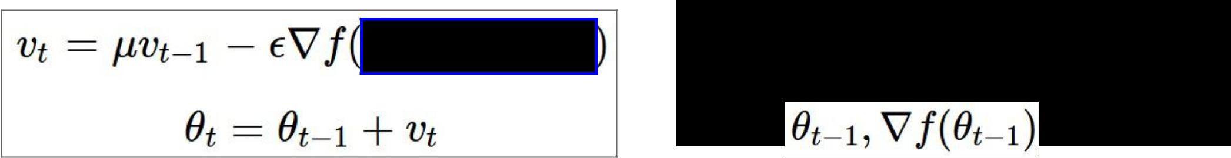

Slightly inconvenient… usually we have :



Fei-Fei Li & Andrej Karpathy & Justin Johnson Lecture 6 23 25 Jan 2016

Nesterov Momentum update



Slightly inconvenient… usually we have :



Variable transform and rearranging saves the day:



Fei-Fei Li & Andrej Karpathy & Justin Johnson Lecture 6 24 25 Jan 2016

Nesterov Momentum update



Slightly inconvenient… usually we have :

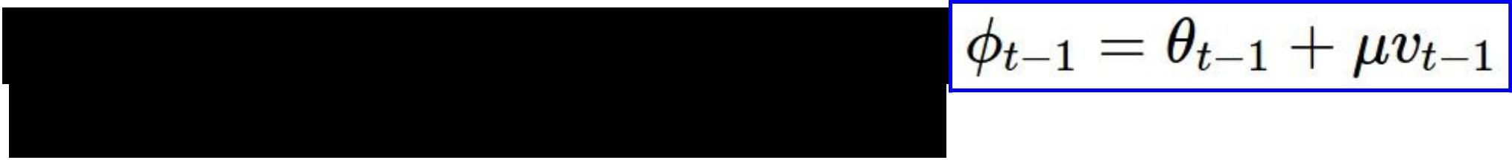

Variable transform and rearranging saves the day:

Replace all thetas with phis, rearrange and obtain:

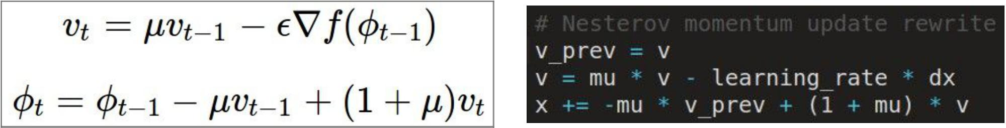

Fei-Fei Li & Andrej Karpathy & Justin Johnson Lecture 6 25 25 Jan 2016

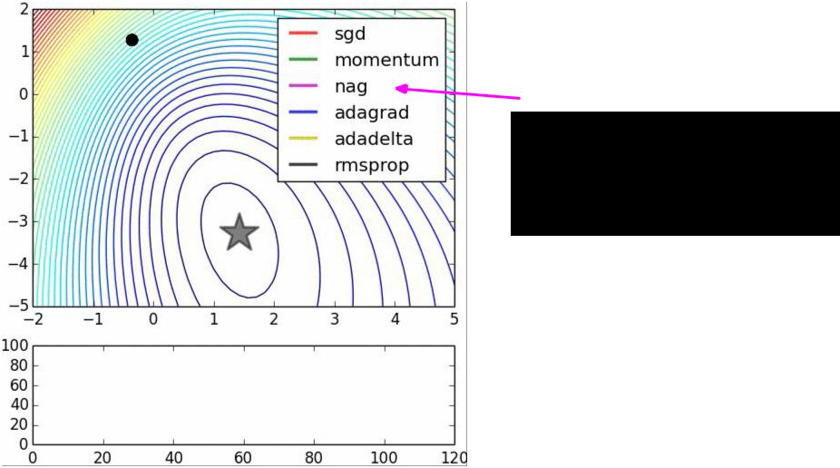

nag =

Nesterov

Accelerated

Gradient



Fei-Fei Li & Andrej Karpathy & Justin Johnson Lecture 6 26 25 Jan 2016



AdaGrad update

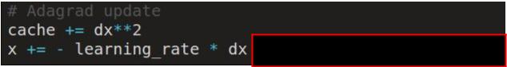

[Duchi et al., 2011]

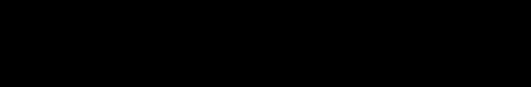

Added element-wise scaling of the gradient based on the historical sum of squares in each dimension



Fei-Fei Li & Andrej Karpathy & Justin Johnson Lecture 6 27 25 Jan 2016

AdaGrad update

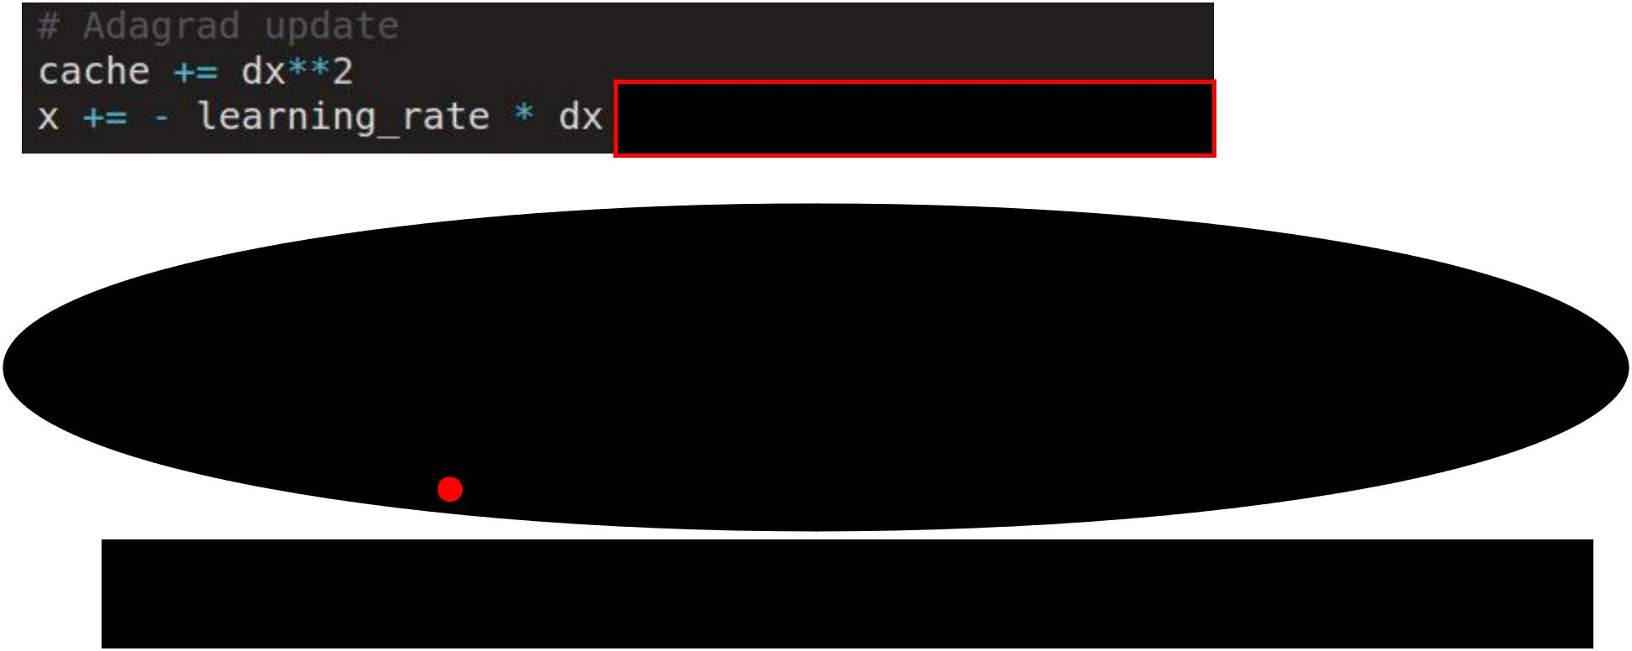

Q: What happens with AdaGrad?



Fei-Fei Li & Andrej Karpathy & Justin Johnson Lecture 6 28 25 Jan 2016

AdaGrad update



Q2: What happens to the step size over long time?



Fei-Fei Li & Andrej Karpathy & Justin Johnson Lecture 6 29 25 Jan 2016

RMSProp update

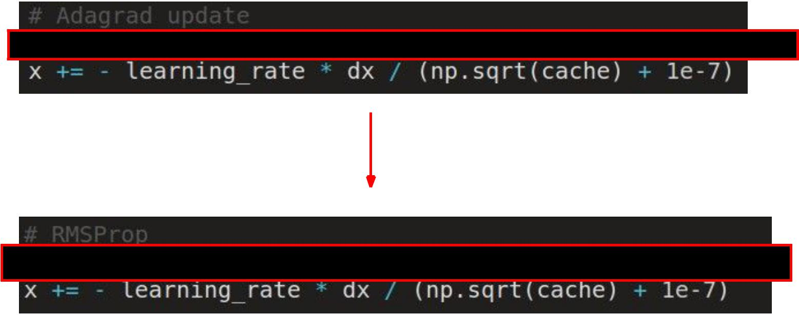

[Tieleman and Hinton, 2012]



Fei-Fei Li & Andrej Karpathy & Justin Johnson Lecture 6 30 25 Jan 2016

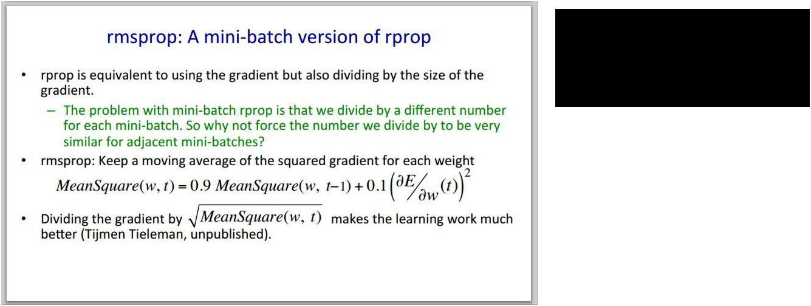Introduced in a slide in Geoff Hinton’s Coursera class, lecture 6



Fei-Fei Li & Andrej Karpathy & Justin Johnson Lecture 6 31 25 Jan 2016

Introduced in a slide in Geoff Hinton’s Coursera class, lecture 6



Cited by several papers as:



Fei-Fei Li & Andrej Karpathy & Justin Johnson Lecture 6 32 25 Jan 2016

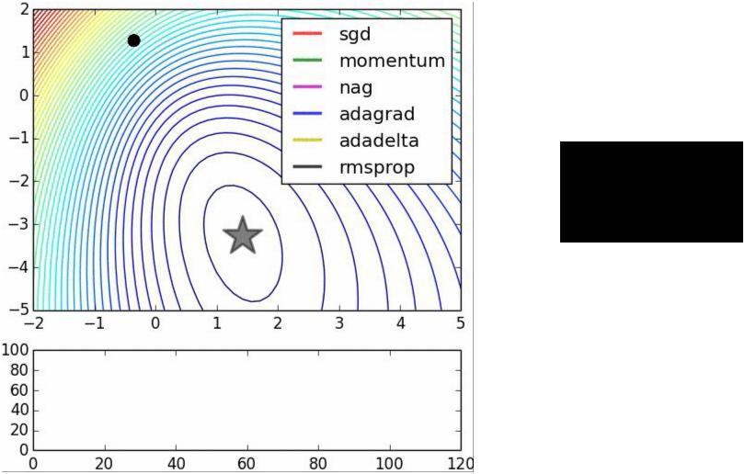

adagrad

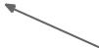

rmsprop



Fei-Fei Li & Andrej Karpathy & Justin Johnson Lecture 6 33 25 Jan 2016

Adam update



[Kingma and Ba, 2014]



(incomplete, but close)

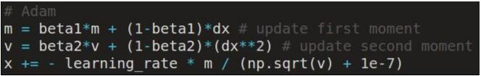

Fei-Fei Li & Andrej Karpathy & Justin Johnson Lecture 6 34 25 Jan 2016

|  |  |  |
| --- | --- | --- |
| Adam update | [Kingma and Ba, 2014] |  |
|  |  |
| (incomplete, but close) |  |  |



momentum

RMSProp-like

Looks a bit like RMSProp with momentum



Fei-Fei Li & Andrej Karpathy & Justin Johnson Lecture 6 35 25 Jan 2016

|  |  |  |
| --- | --- | --- |
| Adam update | [Kingma and Ba, 2014] |  |
|  |  |
| (incomplete, but close) |  |  |

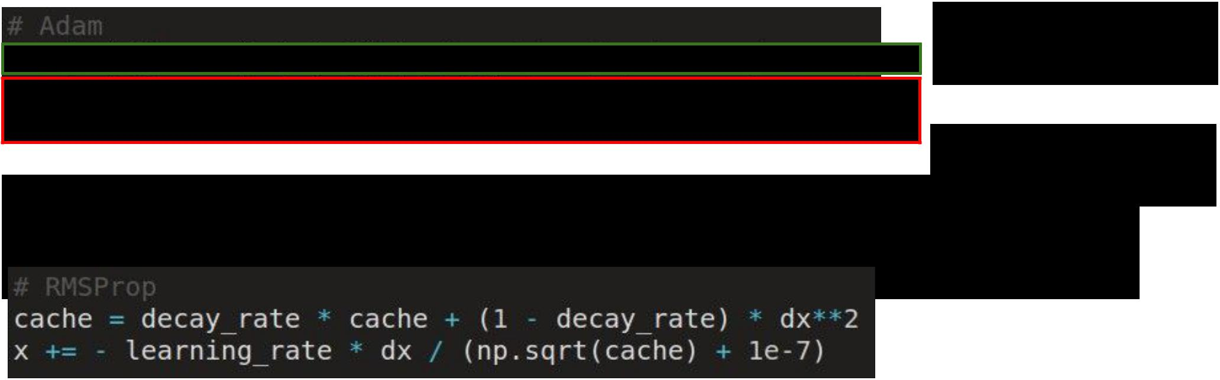

momentum

RMSProp-like

Looks a bit like RMSProp with momentum



Fei-Fei Li & Andrej Karpathy & Justin Johnson Lecture 6 36 25 Jan 2016

Adam update

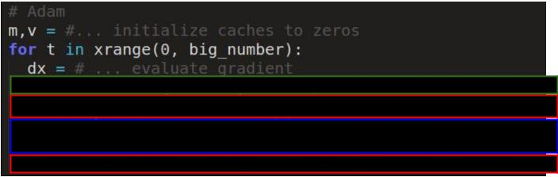

[Kingma and Ba, 2014]



momentum

bias correction

(only relevant in first few iterations when t is small)



RMSProp-like

The bias correction compensates for the fact that m,v are initialized at zero and need some time to “warm up”.



Fei-Fei Li & Andrej Karpathy & Justin Johnson Lecture 6 37 25 Jan 2016

SGD, SGD+Momentum, Adagrad, RMSProp, Adam all have **learning rate** as a hyperparameter.

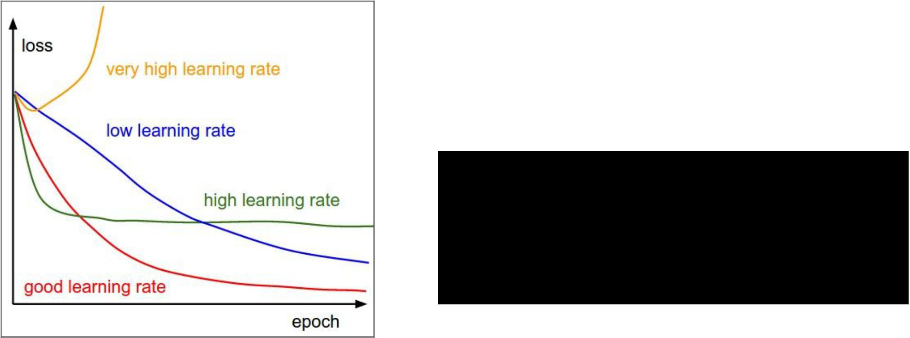

Q: Which one of these learning rates is best to use?



Fei-Fei Li & Andrej Karpathy & Justin Johnson Lecture 6 38 25 Jan 2016

SGD, SGD+Momentum, Adagrad, RMSProp, Adam all have **learning rate** as a hyperparameter.

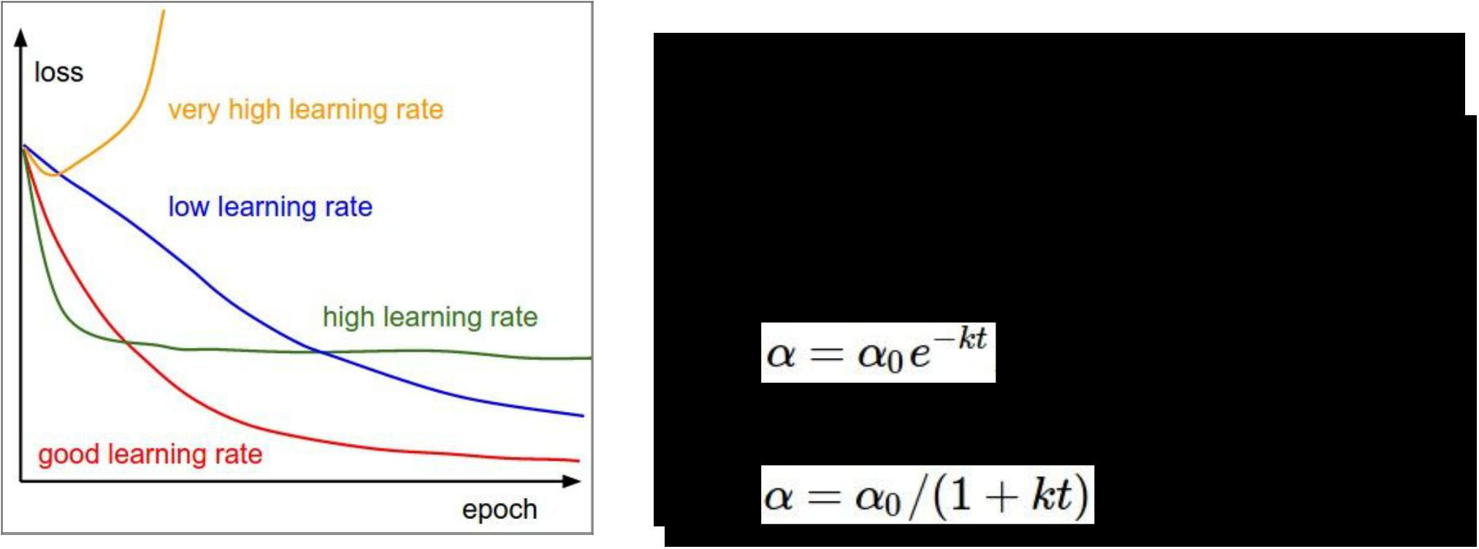

**=> Learning rate decay over time!**

**step decay:**

e.g. decay learning rate by half every few epochs.

**exponential decay:**

**1/t decay:**



Fei-Fei Li & Andrej Karpathy & Justin Johnson Lecture 6 39 25 Jan 2016

Second order optimization methods

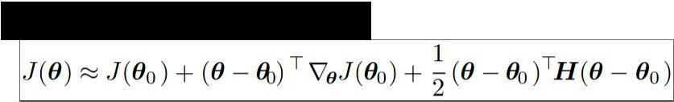

second-order Taylor expansion:



Solving for the critical point we obtain the Newton parameter update:

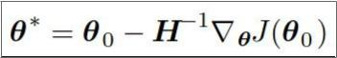

Q: what is nice about this update?



Fei-Fei Li & Andrej Karpathy & Justin Johnson Lecture 6 40 25 Jan 2016

Second order optimization methods



second-order Taylor expansion:



Solving for the critical point we obtain the Newton parameter update:



notice:

no hyperparameters! (e.g. learning rate)



Q2: why is this impractical for training Deep Neural Nets?



Fei-Fei Li & Andrej Karpathy & Justin Johnson Lecture 6 41 25 Jan 2016

Second order optimization methods



* Quasi-Newton methods (**BGFS** most popular): *instead of inverting the Hessian (O(n^3)), approximate inverse Hessian with rank 1 updates over time (O(n^2) each).*
* **L-BFGS** (Limited memory BFGS):

*Does not form/store the full inverse Hessian.*



Fei-Fei Li & Andrej Karpathy & Justin Johnson Lecture 6 42 25 Jan 2016

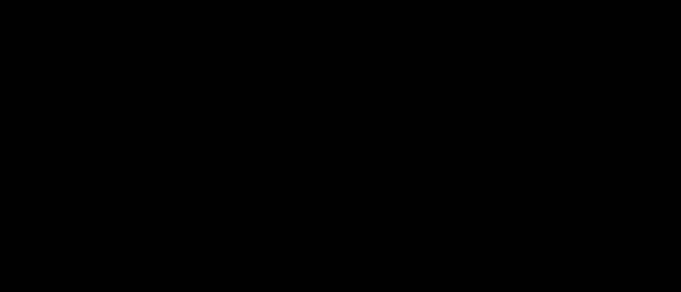**L-BFGS**

* **Usually works very well in full batch, deterministic mode** i.e. if you have a single, deterministic f(x) then L-BFGS will probably work very nicely
* **Does not transfer very well to mini-batch setting**. Givesbad results. Adapting L-BFGS to large-scale, stochastic setting is an active area of research.



Fei-Fei Li & Andrej Karpathy & Justin Johnson Lecture 6 43 25 Jan 2016

In practice:



* **Adam** is a good default choice in most cases
* If you can afford to do full batch updates then try out

**L-BFGS** (and don’t forget to disable all sources of noise)



Fei-Fei Li & Andrej Karpathy & Justin Johnson Lecture 6 44 25 Jan 2016



Evaluation:

Model Ensembles



Fei-Fei Li & Andrej Karpathy & Justin Johnson Lecture 6 45 25 Jan 2016



1. Train multiple independent models
2. At test time average their results

Enjoy 2% extra performance



Fei-Fei Li & Andrej Karpathy & Justin Johnson Lecture 6 46 25 Jan 2016

Fun Tips/Tricks:

* can also get a small boost from averaging multiple model checkpoints of a single model.



Fei-Fei Li & Andrej Karpathy & Justin Johnson Lecture 6 47 25 Jan 2016

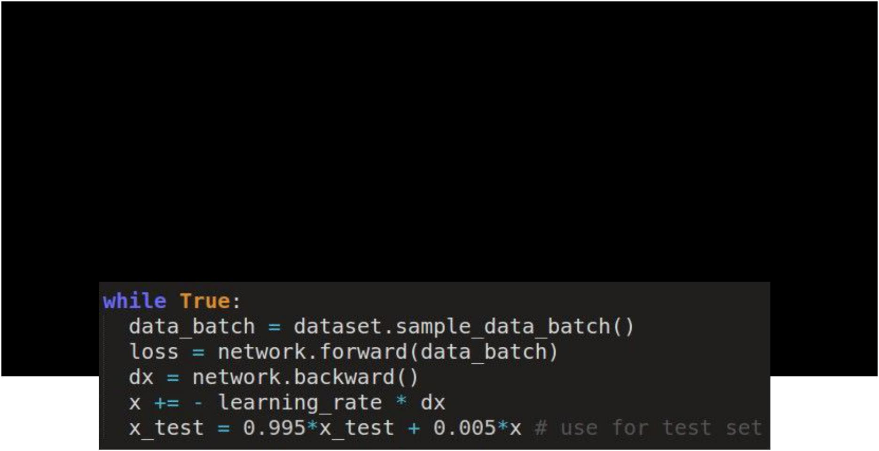Fun Tips/Tricks:

* can also get a small boost from averaging multiple model checkpoints of a single model.
* keep track of (and use at test time) a running average parameter vector:



Fei-Fei Li & Andrej Karpathy & Justin Johnson Lecture 6 48 25 Jan 2016



Regularization **(dropout)**



Fei-Fei Li & Andrej Karpathy & Justin Johnson Lecture 6 49 25 Jan 2016

Regularization: **Dropout**

“randomly set some neurons to zero in the forward pass”

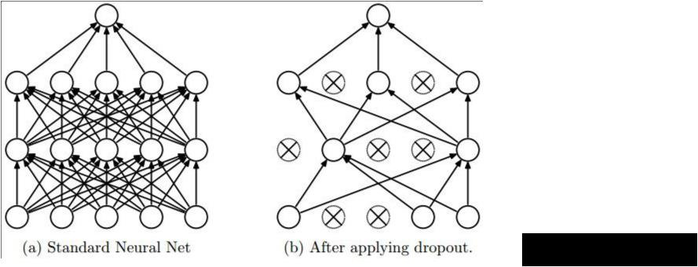

*[Srivastava et al., 2014]*



Fei-Fei Li & Andrej Karpathy & Justin Johnson Lecture 6 50 25 Jan 2016

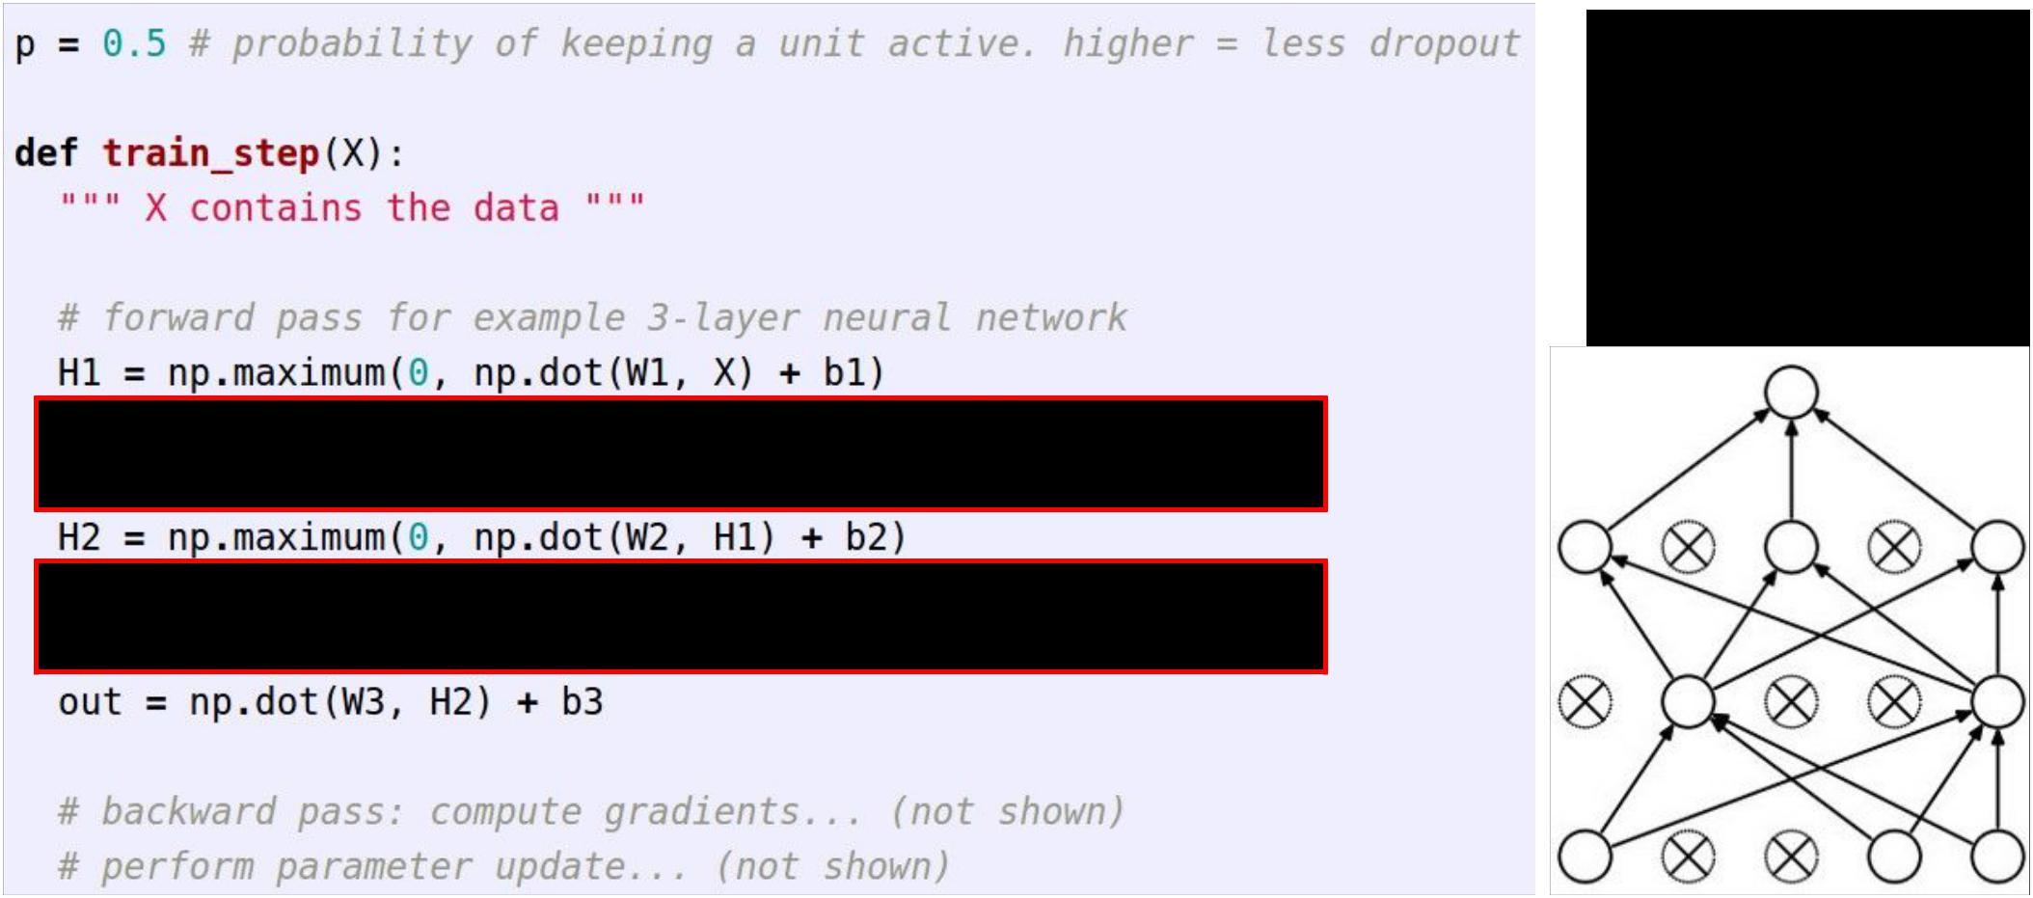Example forward pass with a 3-layer network using dropout



Fei-Fei Li & Andrej Karpathy & Justin Johnson Lecture 6 51 25 Jan 2016

Waaaait a second…

How could this possibly be a good idea?

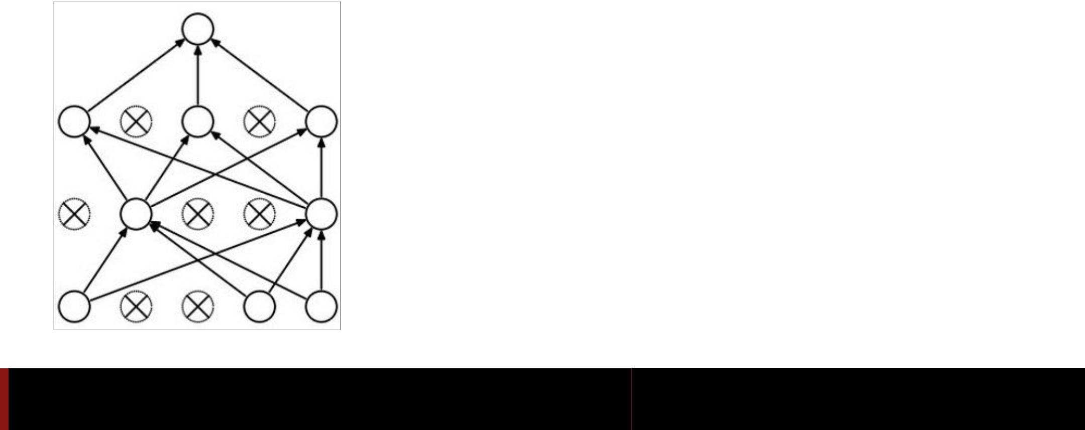

Fei-Fei Li & Andrej Karpathy & Justin Johnson Lecture 6 52 25 Jan 2016

Waaaait a second…

How could this possibly be a good idea?

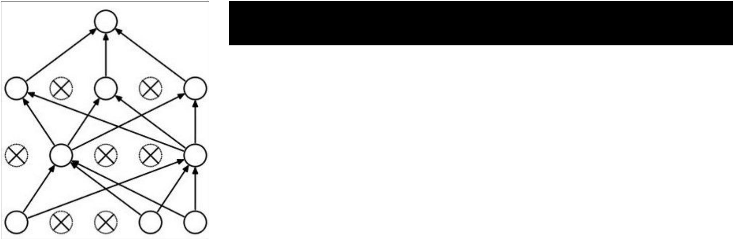

Forces the network to have a redundant representation.

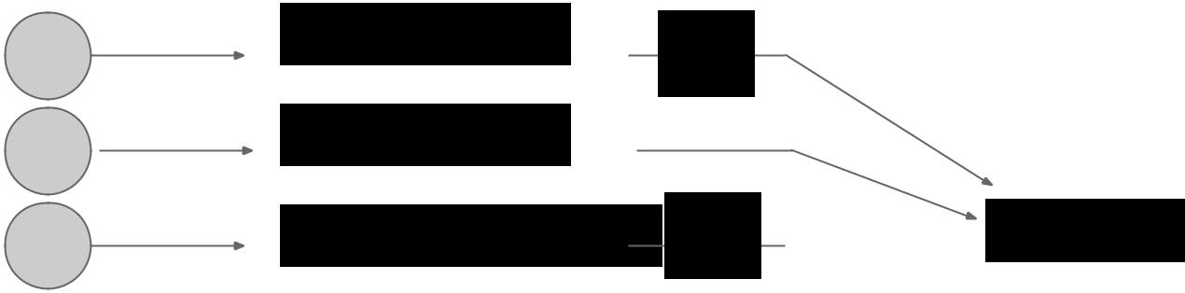

has an ear



has a tail



is furry

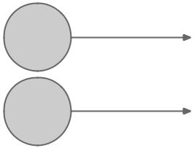

has claws



mischievous



look



Fei-Fei Li & Andrej Karpathy & Justin Johnson Lecture 6

**X**



*  cat

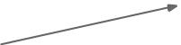 score

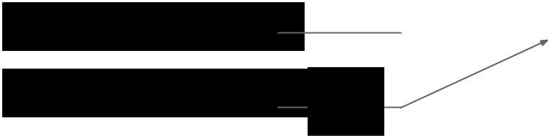

**X**



53 25 Jan 2016

Waaaait a second…

How could this possibly be a good idea?

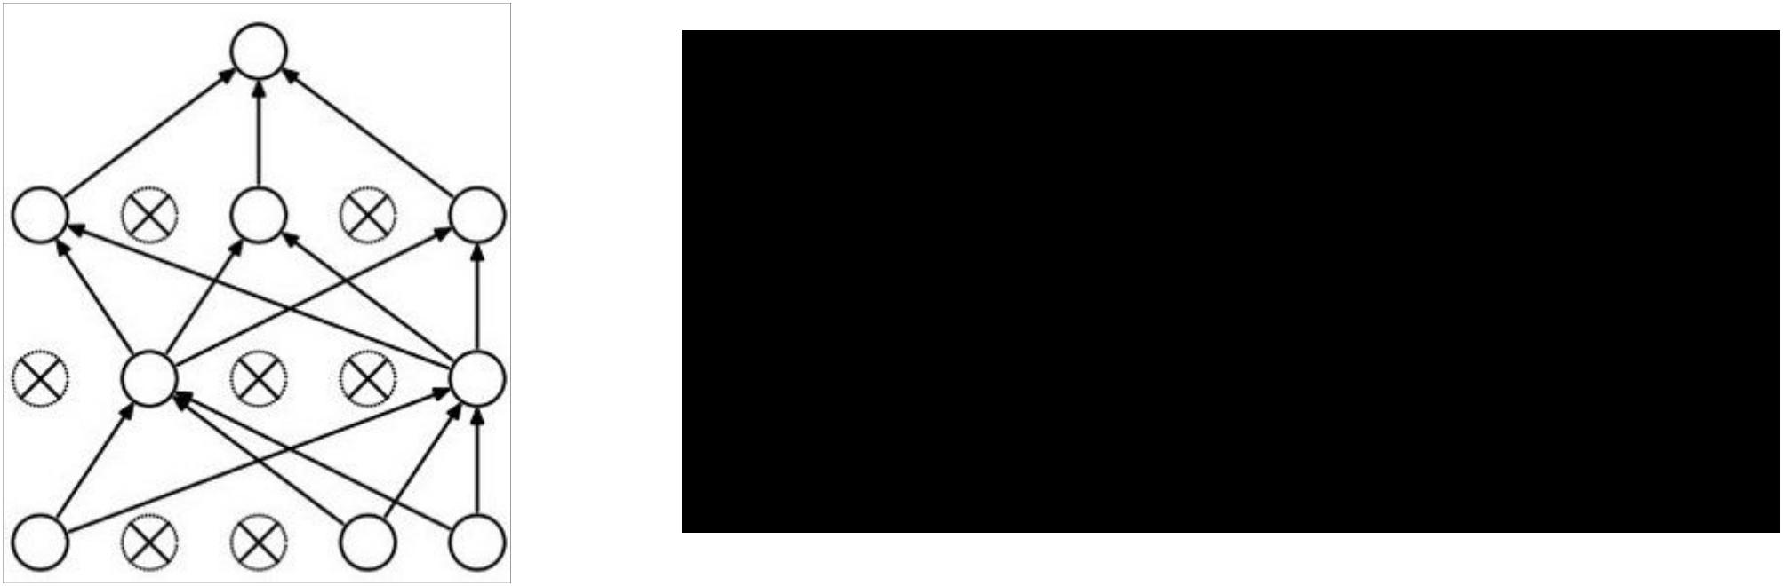

Another interpretation:

Dropout is training a large ensemble of models (that share parameters).

Each binary mask is one model, gets trained on only ~one datapoint.



Fei-Fei Li & Andrej Karpathy & Justin Johnson Lecture 6 54 25 Jan 2016

At test time….



**Ideally**:

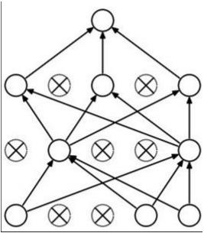

want to integrate out all the noise

**Monte Carlo approximation:** do many forward passes with different dropout masks, average all predictions



Fei-Fei Li & Andrej Karpathy & Justin Johnson Lecture 6 55 25 Jan 2016

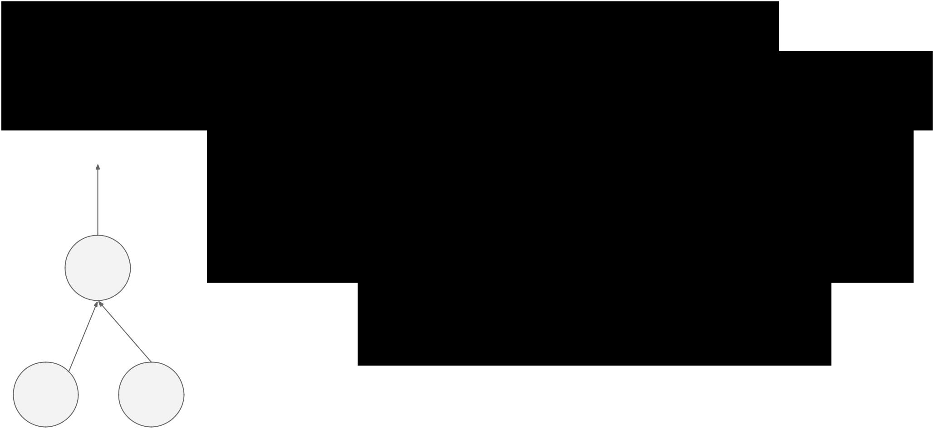At test time….

Can in fact do this with a single forward pass! (approximately) Leave all input neurons turned on (no dropout).



(this can be shown to be an

approximation to evaluating the

whole ensemble)



Fei-Fei Li & Andrej Karpathy & Justin Johnson Lecture 6 56 25 Jan 2016

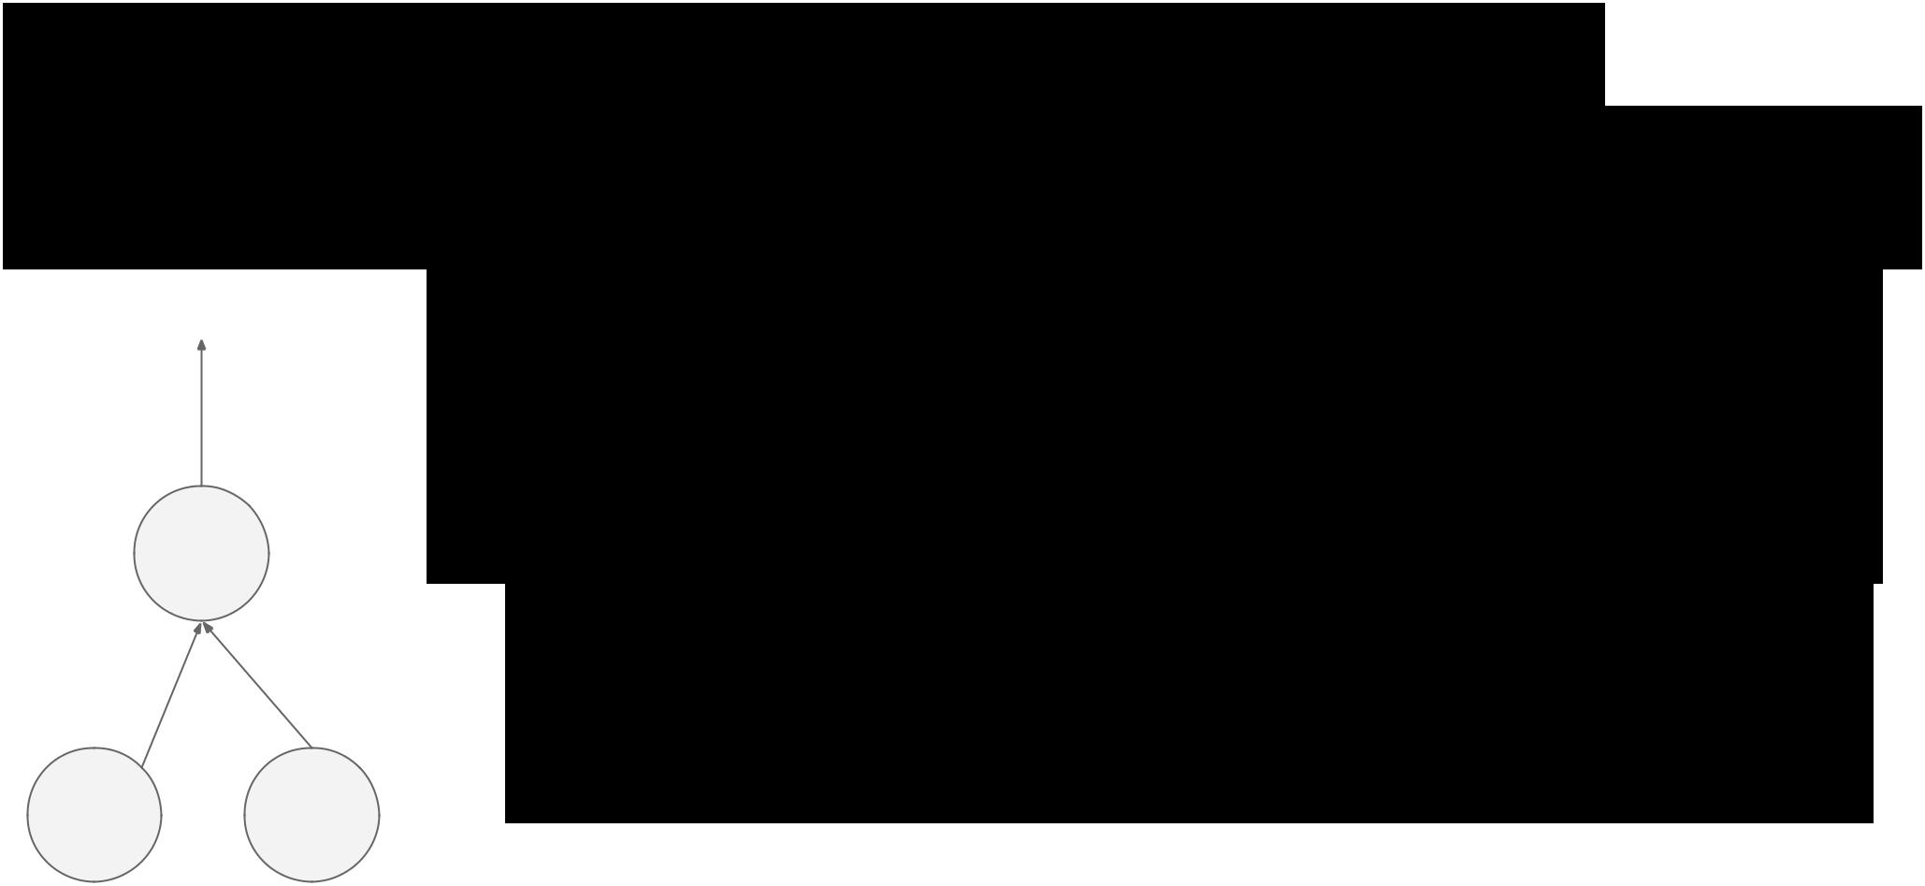At test time….

Can in fact do this with a single forward pass! (approximately) Leave all input neurons turned on (no dropout).



Q: Suppose that with all inputs present at test time the output of this neuron is x.

What would its output be during training time, in expectation? (e.g. if p = 0.5)



Fei-Fei Li & Andrej Karpathy & Justin Johnson Lecture 6 57 25 Jan 2016

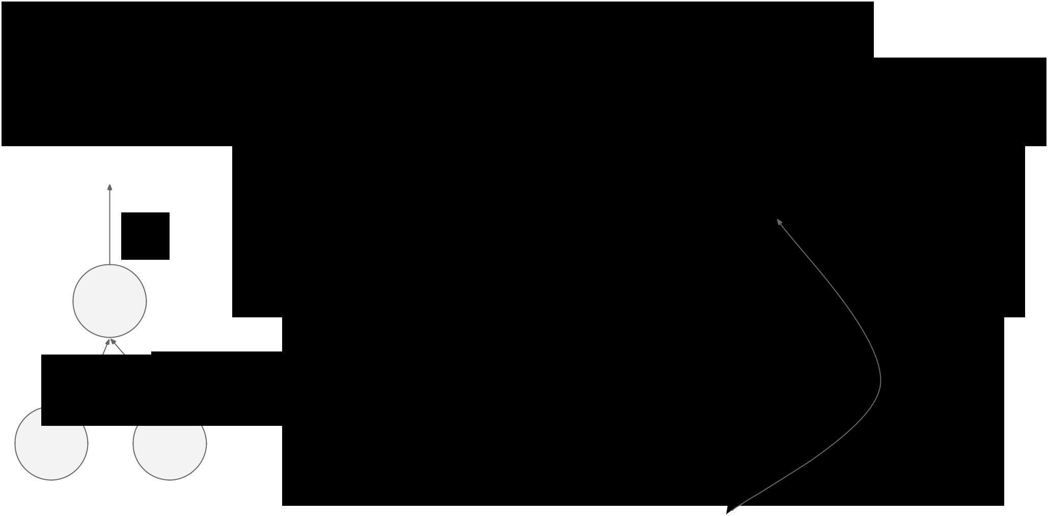At test time….

Can in fact do this with a single forward pass! (approximately)

a



w0 w1

x y

Leave all input neurons turned on (no dropout).

during test: **a = w0*x + w1*y** during train:

E[a] = ¼ * (w0*0 + w1*0

w0*0 + w1*y

* ¼ * (2 w0*x + 2 w1*y)
  + **½ * (w0*x + w1*y)** 



Fei-Fei Li & Andrej Karpathy & Justin Johnson Lecture 6 58 25 Jan 2016

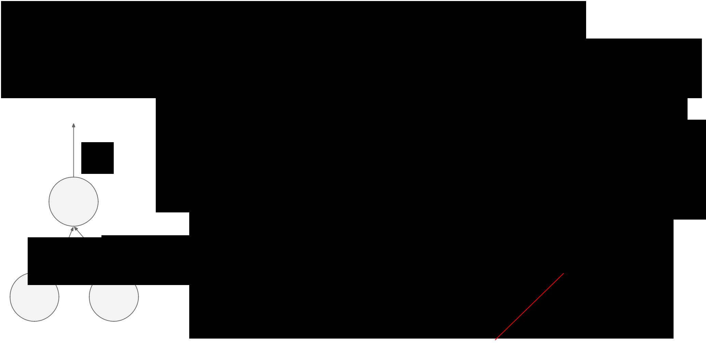At test time….

Can in fact do this with a single forward pass! (approximately) Leave all input neurons turned on (no dropout).

a



w0 w1

x y

during test: **a = w0*x + w1*y** during train:

E[a] = ¼ * (w0*0 + w1*0 w0*0 + w1*y

* ¼ * (2 w0*x + 2 w1*y)
  + **½ * (w0*x + w1*y)** 



With p=0.5, using all inputs in the forward pass would inflate the activations by 2x from what the network was “used to” during training! => Have to compensate by scaling the activations back down by ½

Fei-Fei Li & Andrej Karpathy & Justin Johnson Lecture 6 59 25 Jan 2016

We can do something approximate analytically

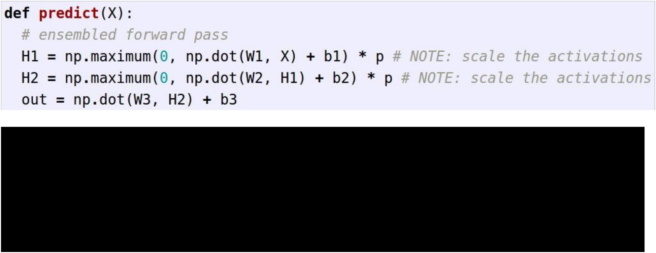

At test time all neurons are active always

=> We must scale the activations so that for each neuron:

output at test time = expected output at training time



Fei-Fei Li & Andrej Karpathy & Justin Johnson Lecture 6 60 25 Jan 2016

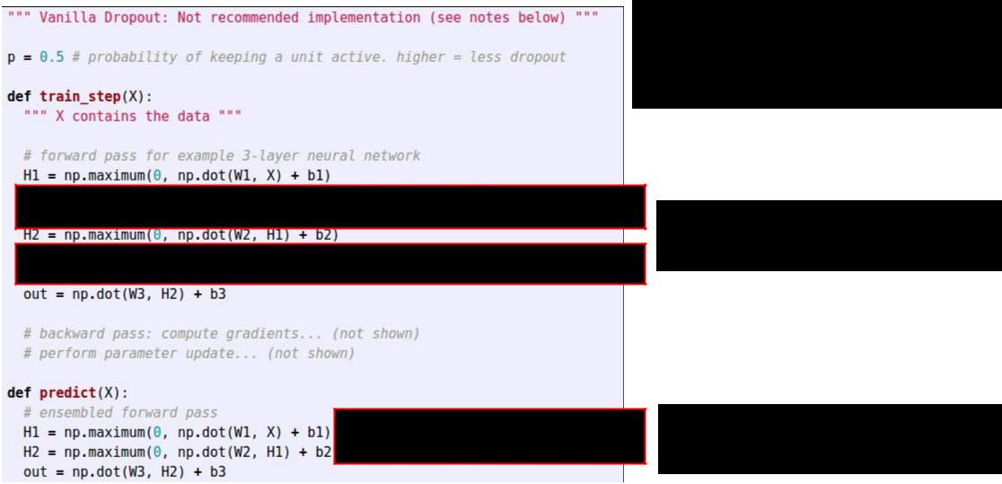Dropout Summary

drop in forward pass

scale at test time



Fei-Fei Li & Andrej Karpathy & Justin Johnson Lecture 6 61 25 Jan 2016

More common: “Inverted dropout”

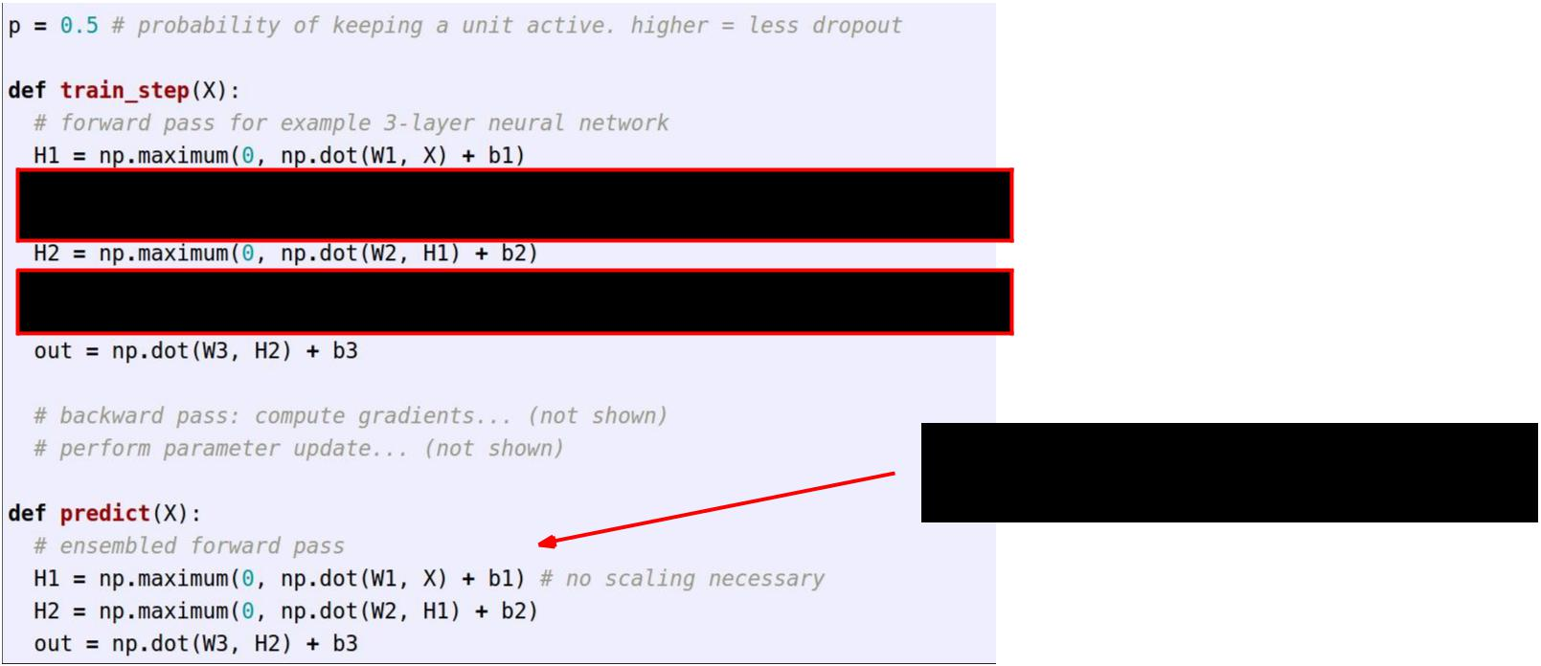

test time is unchanged!



Fei-Fei Li & Andrej Karpathy & Justin Johnson Lecture 6 62 25 Jan 2016



<fun story time>

*(Deep Learning Summer School 2012)*



Fei-Fei Li & Andrej Karpathy & Justin Johnson Lecture 6 63 25 Jan 2016

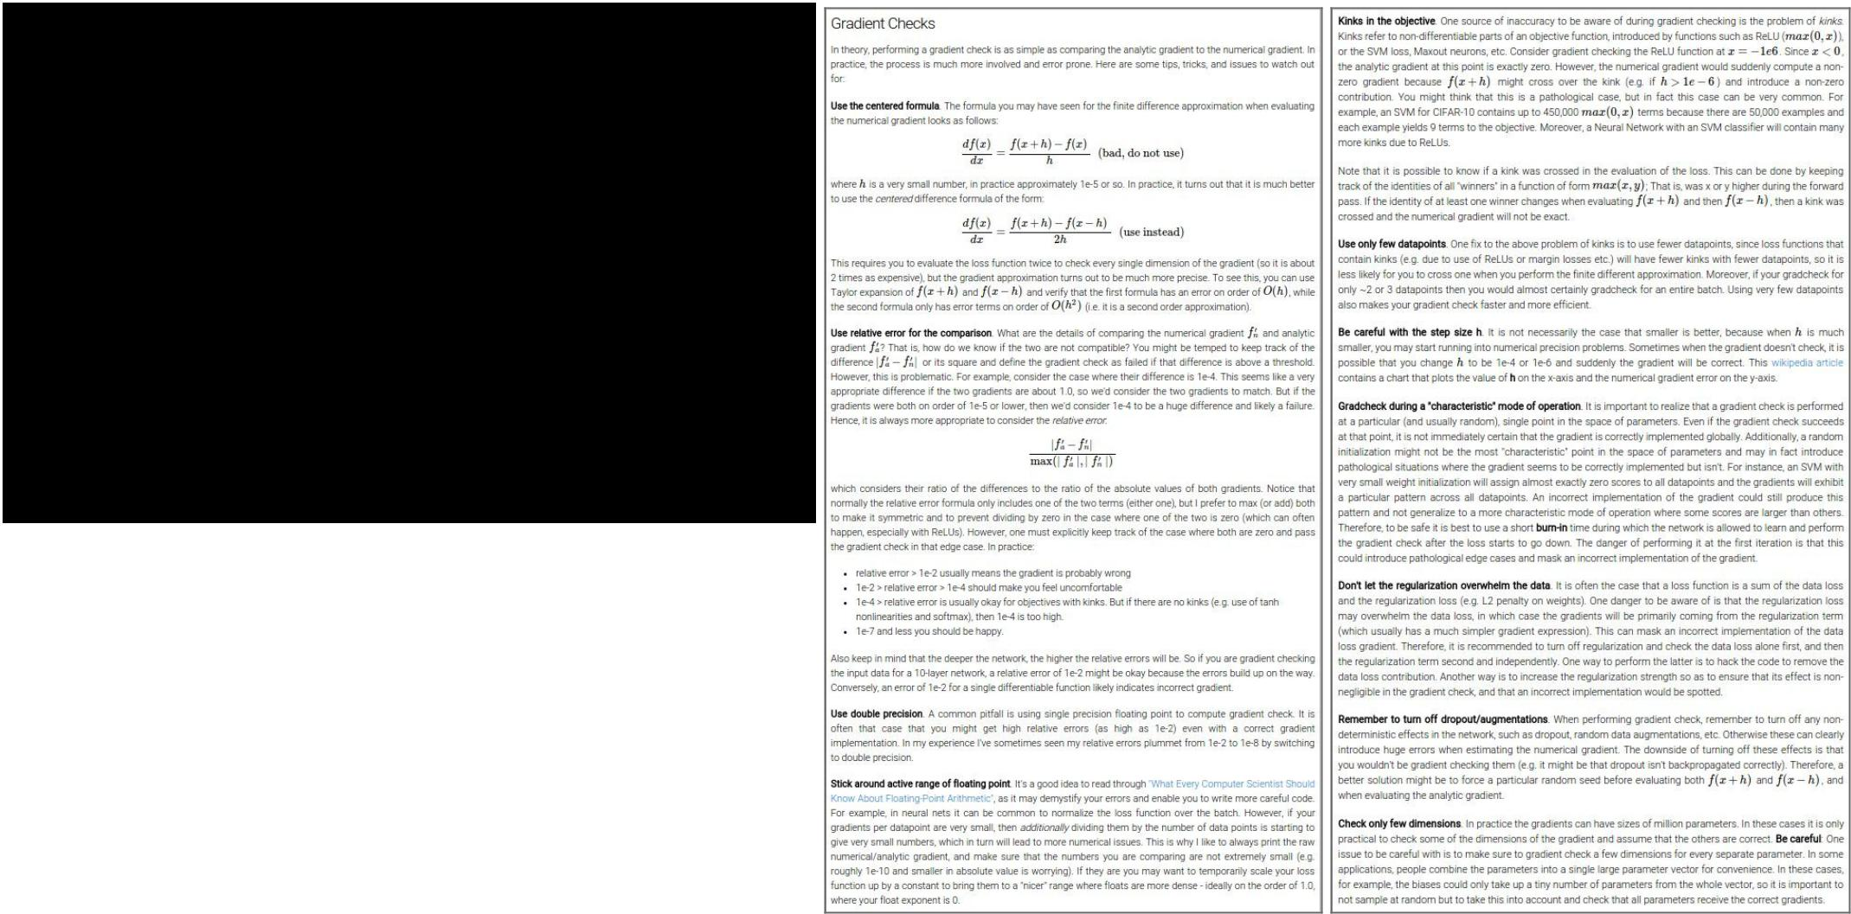Gradient Checking

(see class notes...)

fun guaranteed.



Fei-Fei Li & Andrej Karpathy & Justin Johnson Lecture 6 64 25 Jan 2016

Convolutional Neural Networks

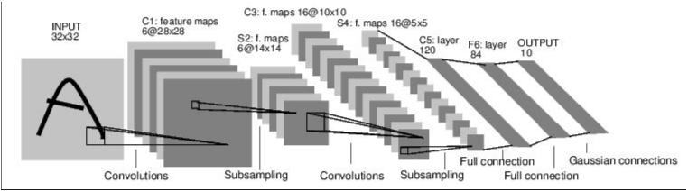

*[LeNet-5, LeCun 1980]*



Fei-Fei Li & Andrej Karpathy & Justin Johnson Lecture 6 65 25 Jan 2016

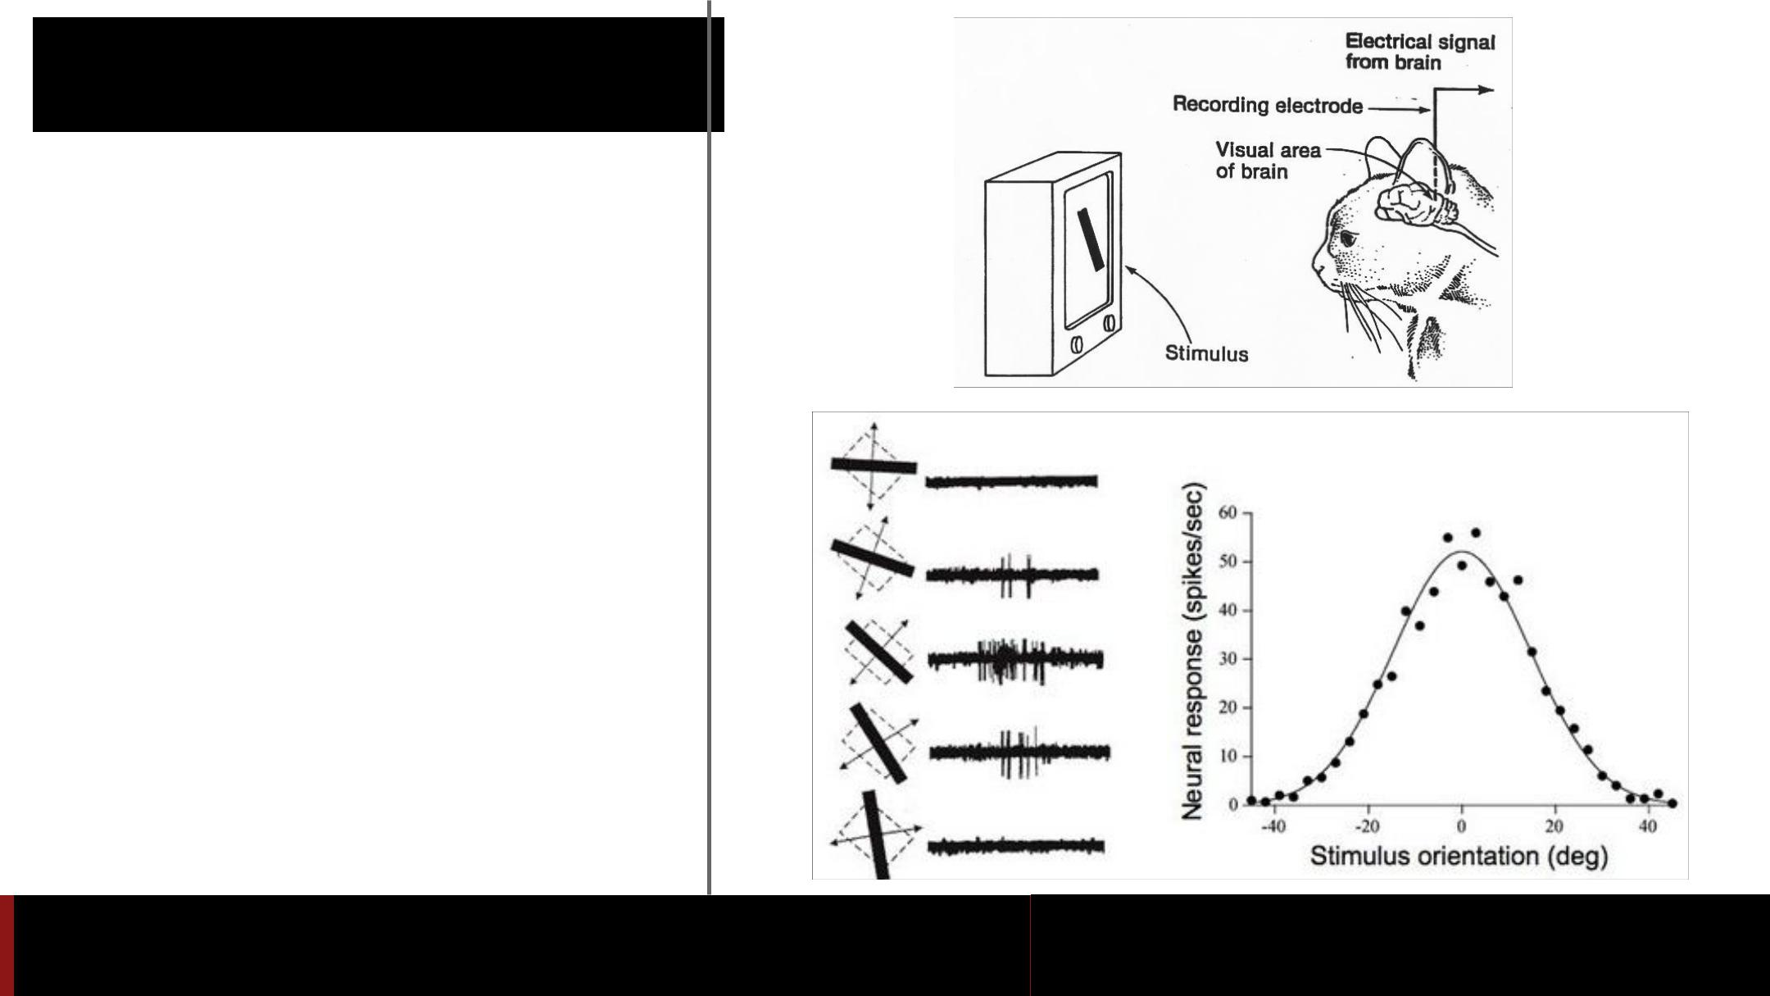A bit of history:

**Hubel & Wiesel**,1959

RECEPTIVE FIELDS OF SINGLE NEURONES IN

THE CAT'S STRIATE CORTEX

1962

RECEPTIVE FIELDS, BINOCULAR INTERACTION

AND FUNCTIONAL ARCHITECTURE IN THE CAT'S VISUAL CORTEX

1968...

Fei-Fei Li & Andrej Karpathy & Justin Johnson Lecture 6 66 25 Jan 2016



Video time [https://youtu.be/8VdFf3egwfg?](https://youtu.be/8VdFf3egwfg?t=1m10s)

[t=1m10s](https://youtu.be/8VdFf3egwfg?t=1m10s)



Fei-Fei Li & Andrej Karpathy & Justin Johnson Lecture 6 67 25 Jan 2016

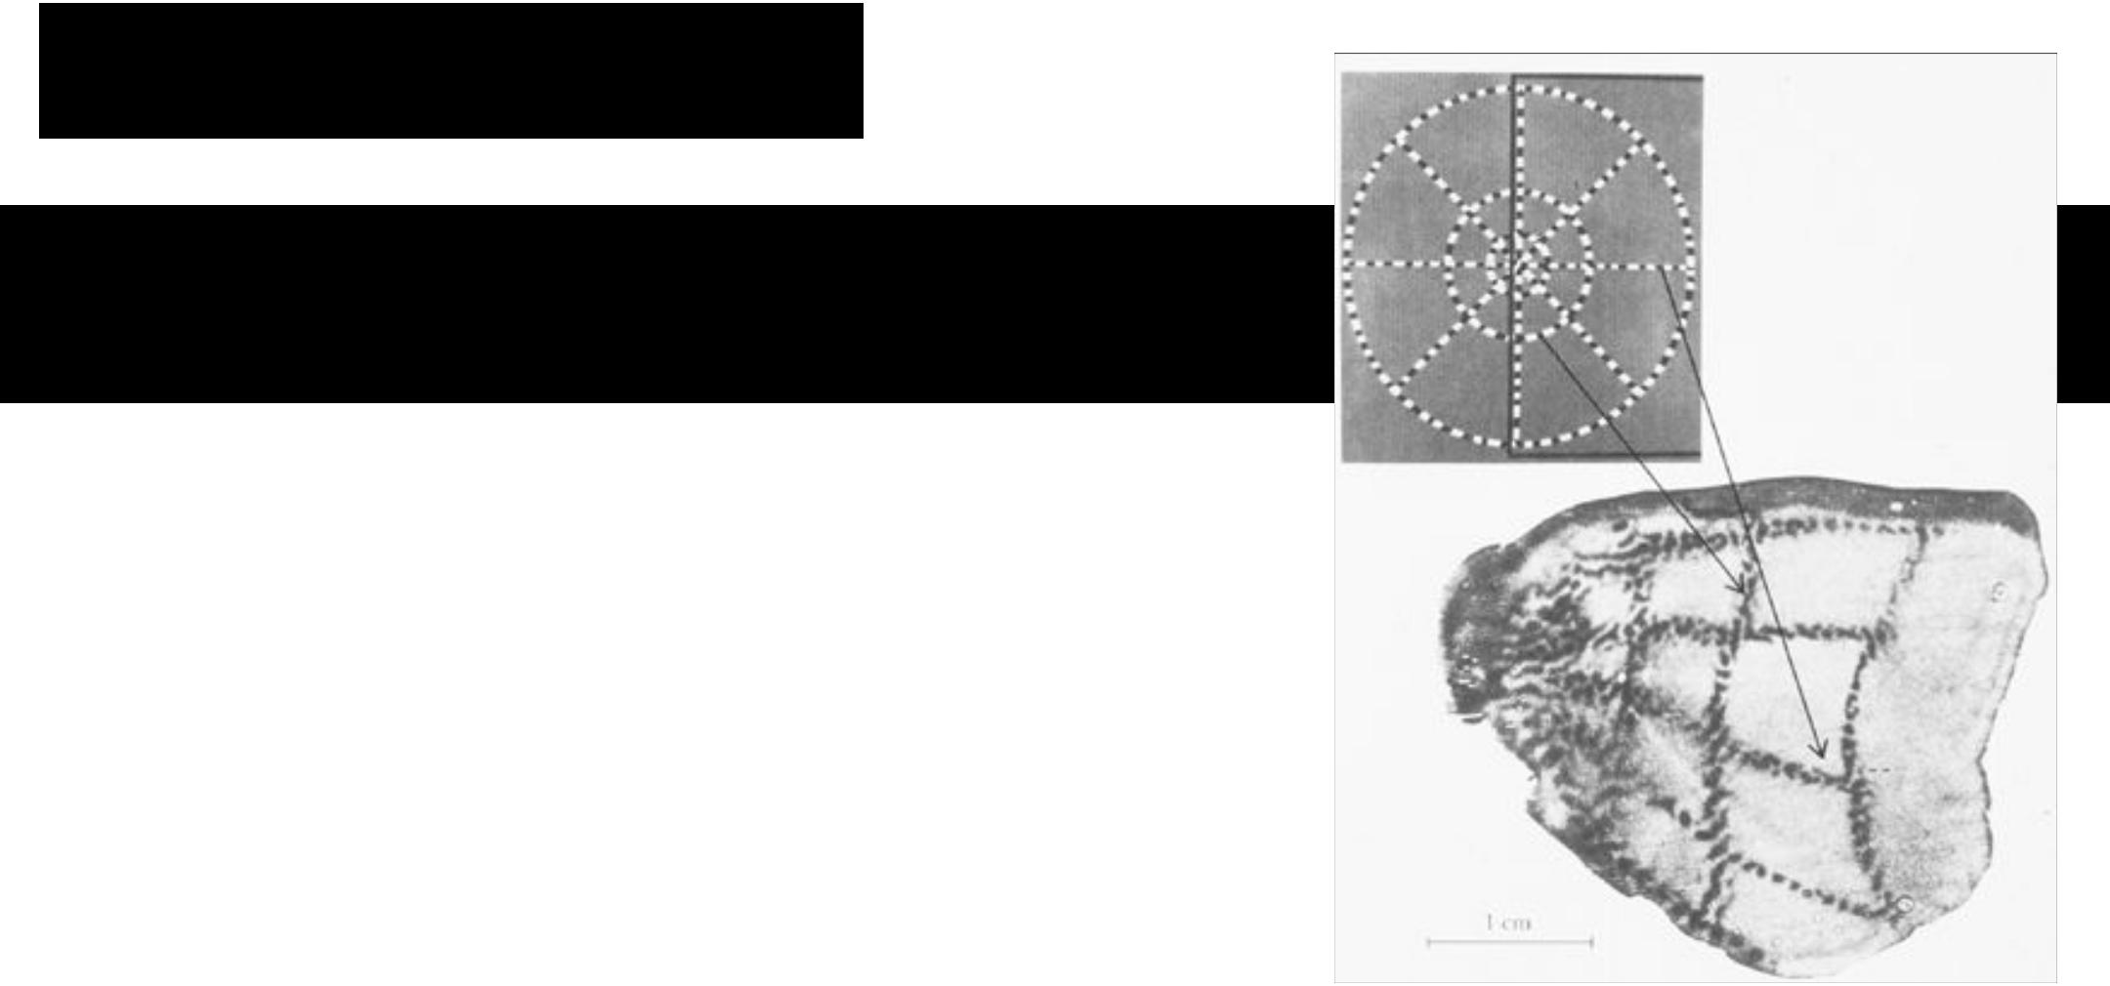A bit of history

**Topographical mapping in the cortex:** nearby cells in cortex represented nearby regions in the visual field



Fei-Fei Li & Andrej Karpathy & Justin Johnson Lecture 6 68 25 Jan 2016

Hierarchical organization

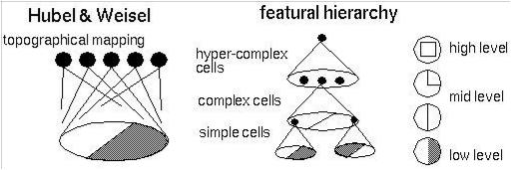

Fei-Fei Li & Andrej Karpathy & Justin Johnson Lecture 6 69 25 Jan 2016

A bit of history:

**Neurocognitron** *[Fukushima 1980]*

“sandwich” architecture (SCSCSC…) simple cells: modifiable parameters complex cells: perform pooling

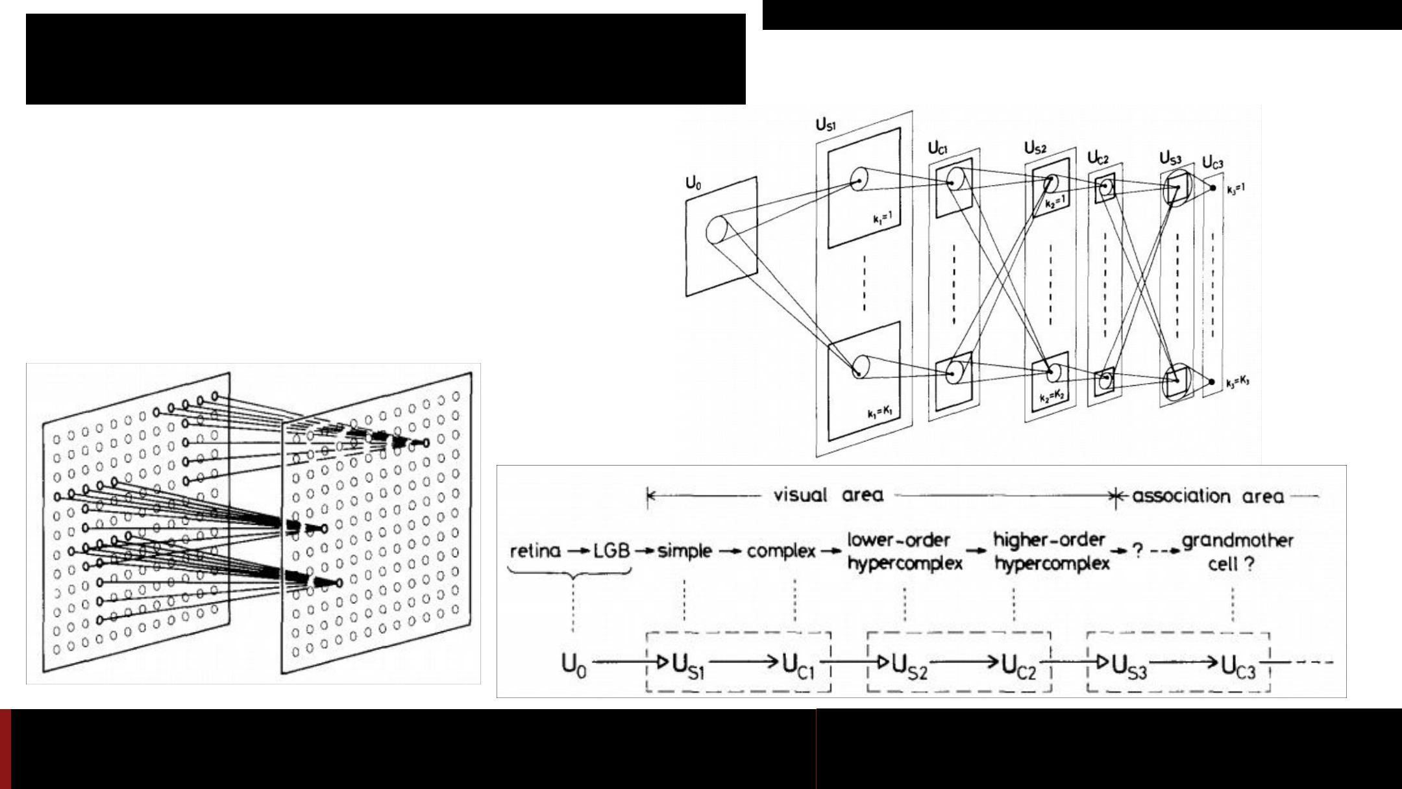

Fei-Fei Li & Andrej Karpathy & Justin Johnson Lecture 6 70 25 Jan 2016

A bit of history:

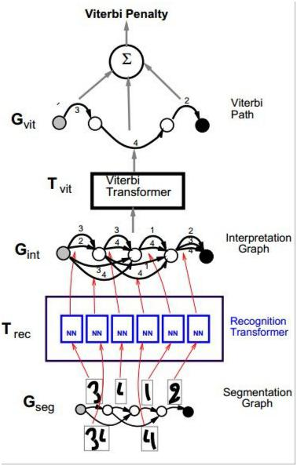

**Gradient-based learning applied to document recognition**

*[LeCun, Bottou, Bengio, Haffner 1998]*

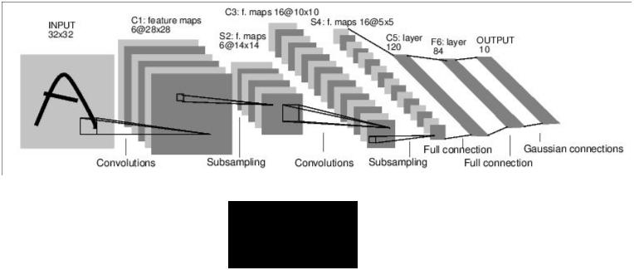

LeNet-5



Fei-Fei Li & Andrej Karpathy & Justin Johnson Lecture 6 71 25 Jan 2016

A bit of history:

**ImageNet Classification with Deep Convolutional Neural Networks** *[Krizhevsky, Sutskever, Hinton, 2012]*

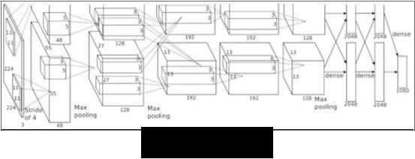

“AlexNet”



Fei-Fei Li & Andrej Karpathy & Justin Johnson Lecture 6 72 25 Jan 2016

Fast-forward to today: ConvNets are everywhere

Classification Retrieval

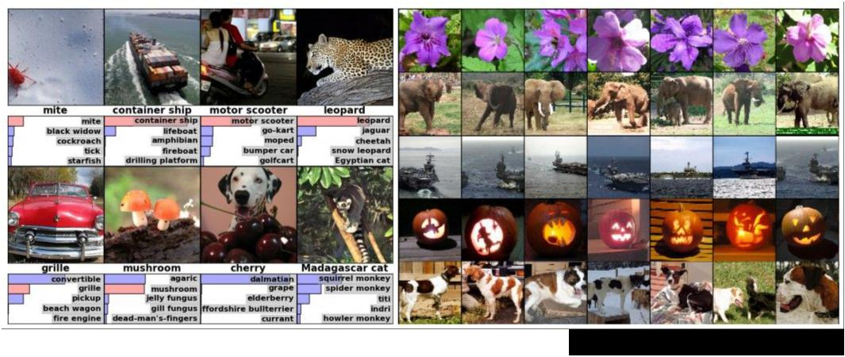

*[Krizhevsky 2012]*



Fei-Fei Li & Andrej Karpathy & Justin Johnson Lecture 6 73 25 Jan 2016

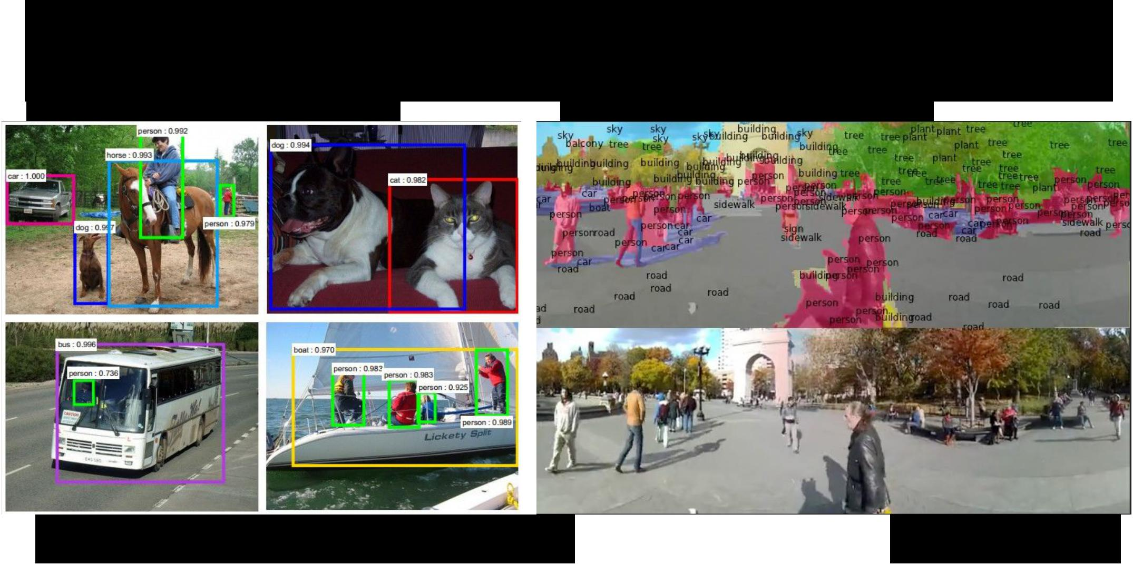Fast-forward to today: ConvNets are everywhere

Detection Segmentation

*[Faster R-CNN: Ren, He, Girshick, Sun 2015]* *[Farabet et al., 2012]*



Fei-Fei Li & Andrej Karpathy & Justin Johnson Lecture 6 74 25 Jan 2016

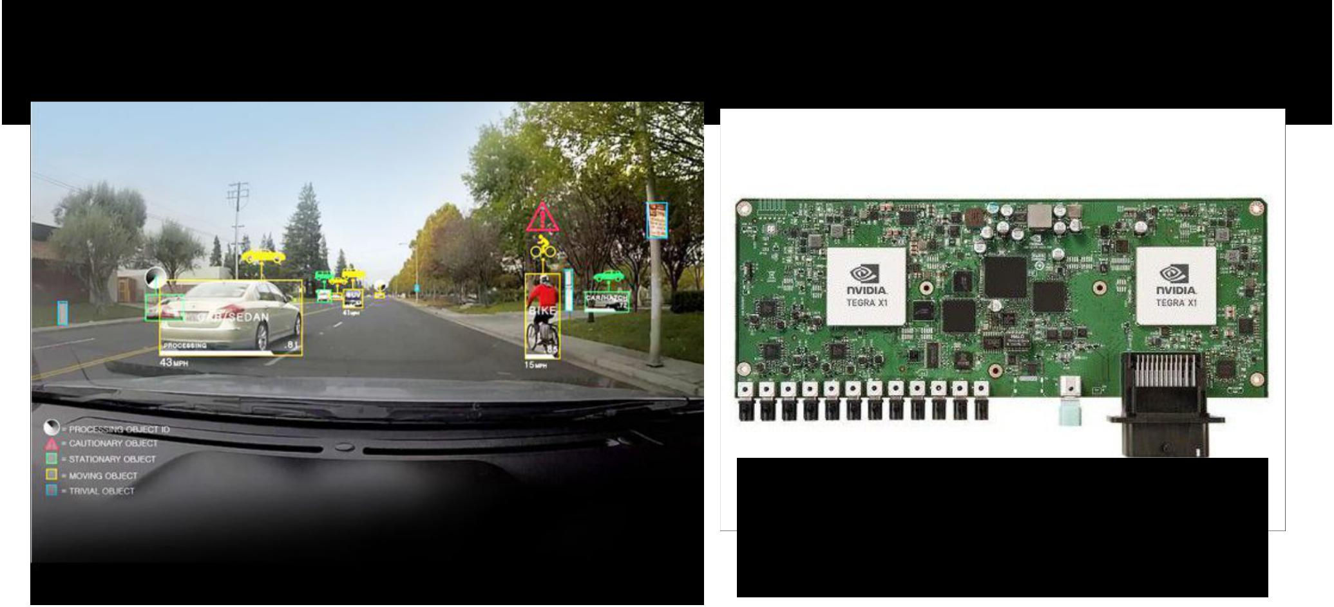Fast-forward to today: ConvNets are everywhere

NVIDIA Tegra X1



self-driving cars



Fei-Fei Li & Andrej Karpathy & Justin Johnson Lecture 6 75 25 Jan 2016

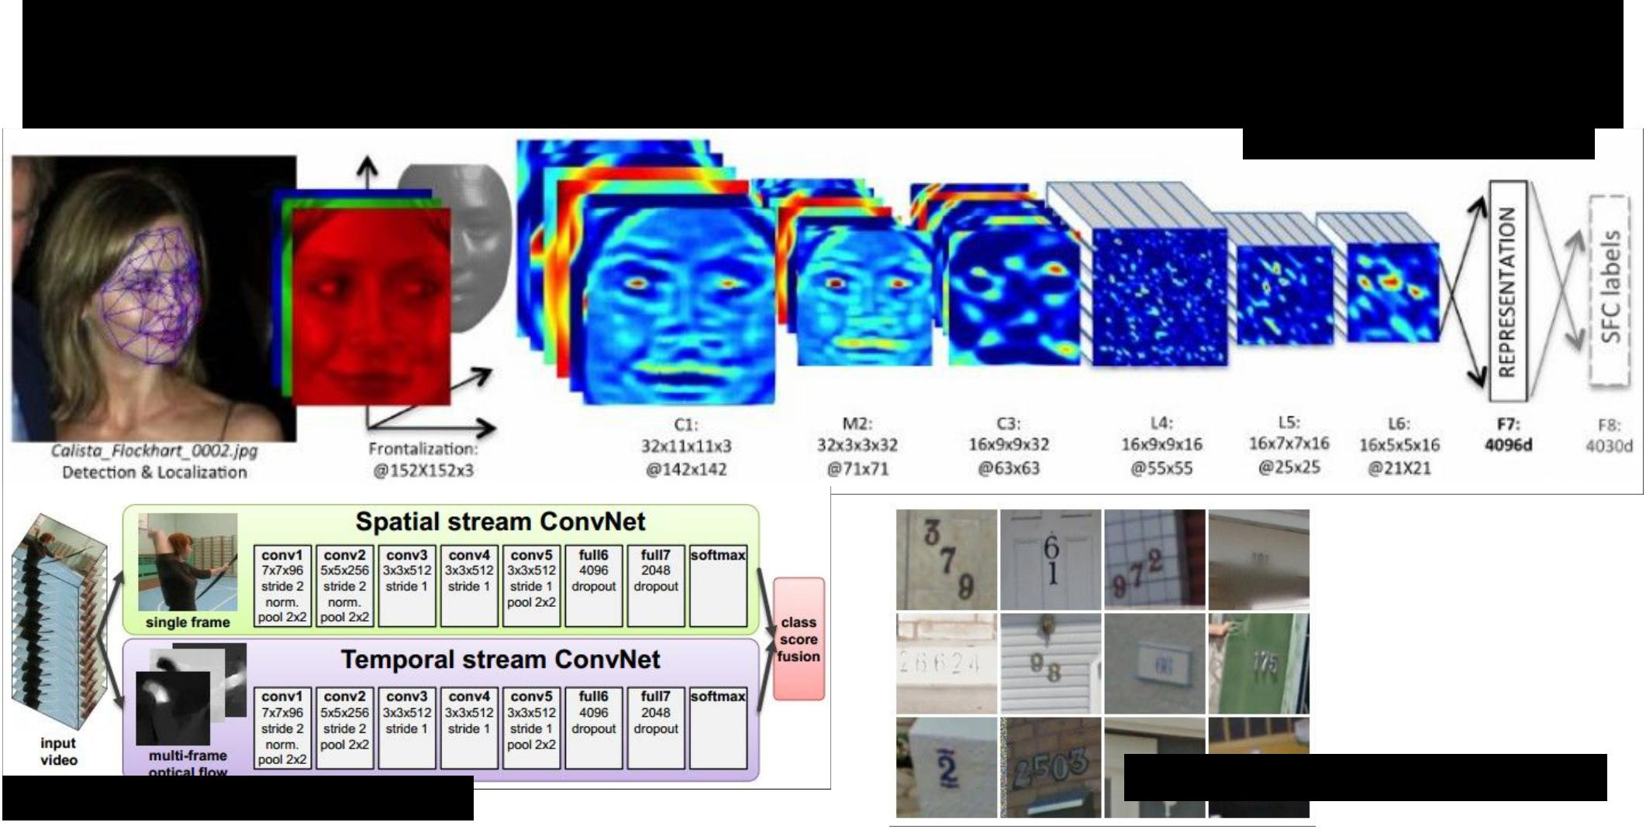Fast-forward to today: ConvNets are everywhere

*[Taigman et al. 2014]*

*[Simonyan et al. 2014]*



*[Goodfellow 2014]*

Fei-Fei Li & Andrej Karpathy & Justin Johnson Lecture 6 76 25 Jan 2016

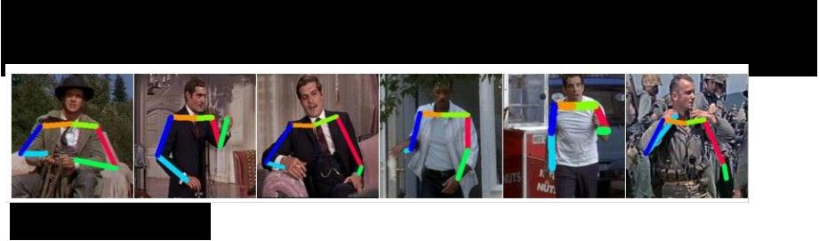Fast-forward to today: ConvNets are everywhere

*[Toshev, Szegedy 2014]*

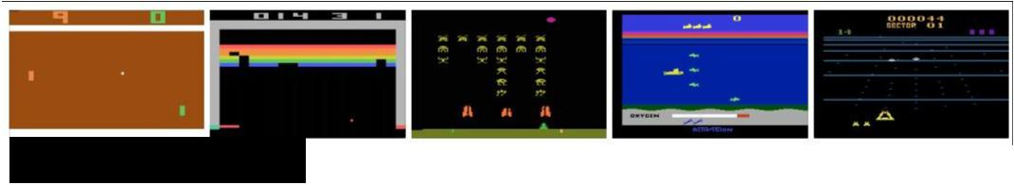

*[Mnih 2013]*



Fei-Fei Li & Andrej Karpathy & Justin Johnson Lecture 6 77 25 Jan 2016

Fast-forward to today: ConvNets are everywhere

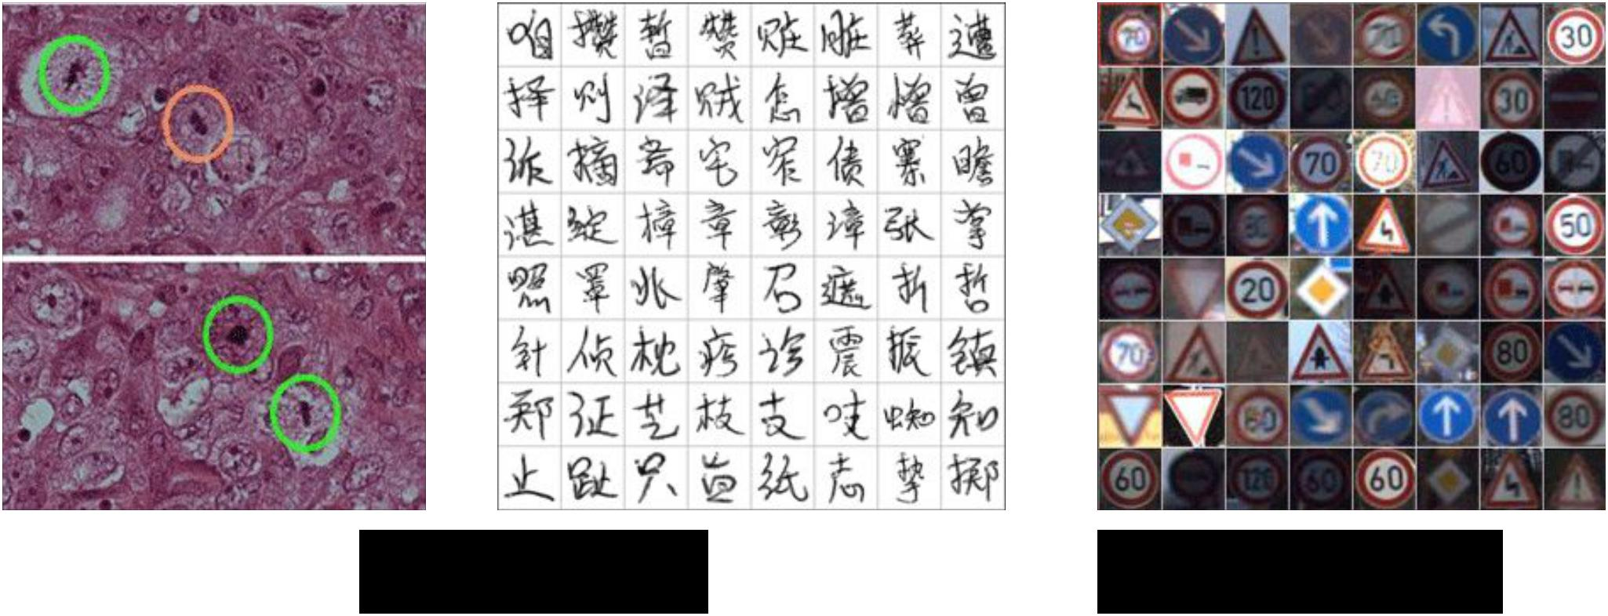

*[Ciresan et al. 2013]* *[Sermanet et al. 2011]*

*[Ciresan et al.]*



Fei-Fei Li & Andrej Karpathy & Justin Johnson Lecture 6 78 25 Jan 2016

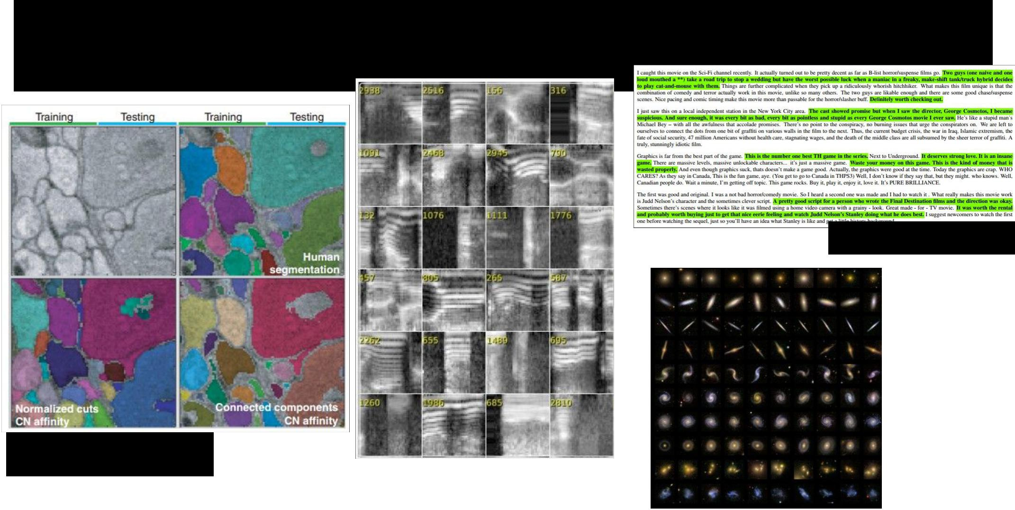Fast-forward to today: ConvNets are everywhere

*[Denil et al. 2014]*

*[Turaga et al., 2010]*



Fei-Fei Li & Andrej Karpathy & Justin Johnson Lecture 6 79 25 Jan 2016

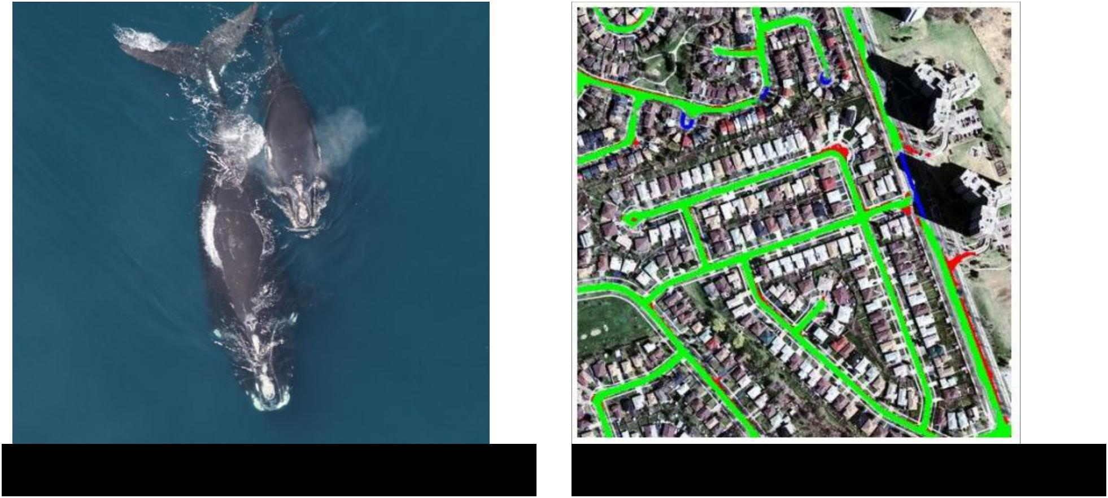

|  |  |  |  |
| --- | --- | --- | --- |
| *Whale recognition, Kaggle Challenge* | *Mnih and Hinton, 2010* | |  |
|  | |  |  |
| Fei-Fei Li & Andrej Karpathy & Justin Johnson | | Lecture 6 80 | 25 Jan 2016 |
|  |  |  |  |



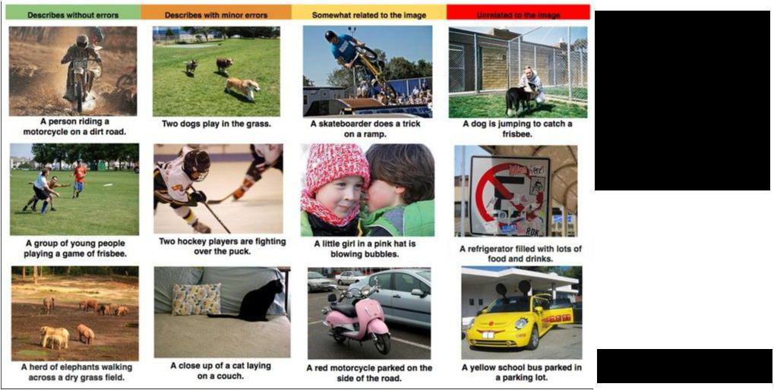Image Captioning

*[Vinyals et al., 2015]*



Fei-Fei Li & Andrej Karpathy & Justin Johnson Lecture 6 81 25 Jan 2016

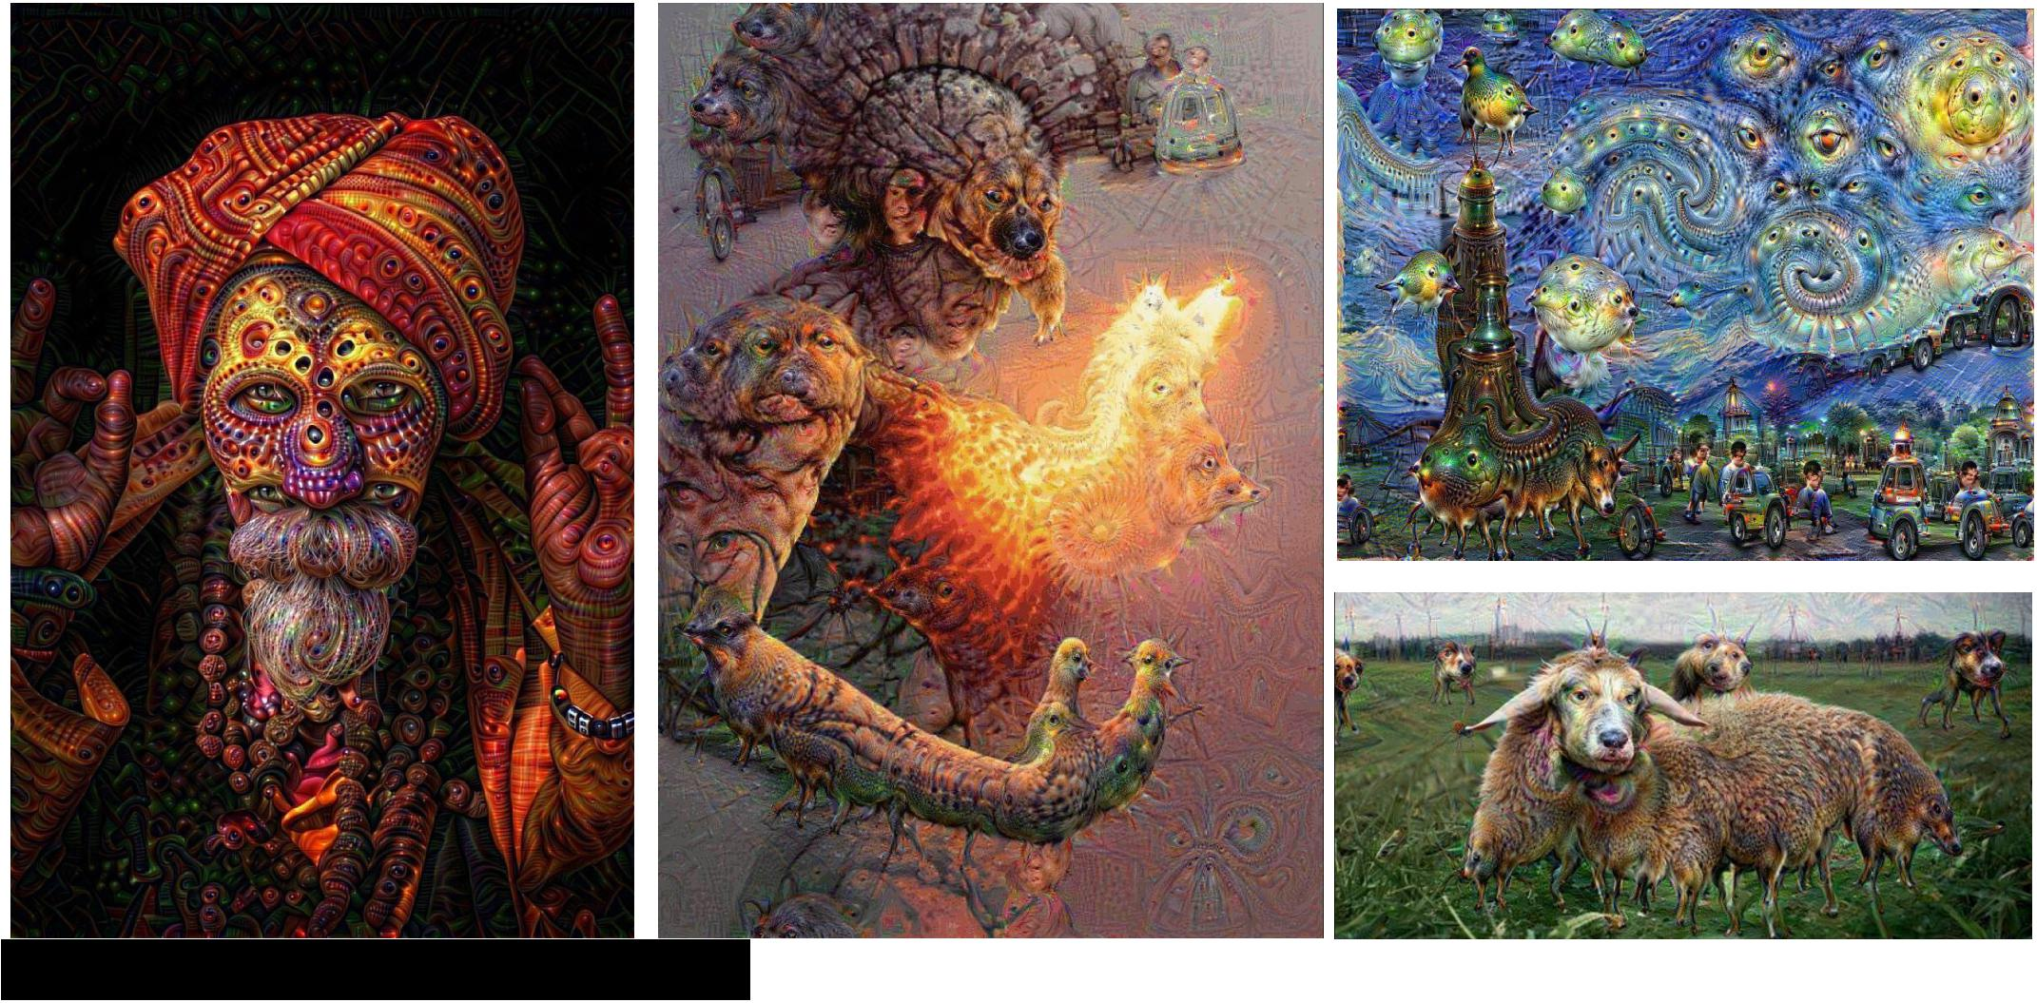

*reddit.com/r/deepdream*



Fei-Fei Li & Andrej Karpathy & Justin Johnson Lecture 6 82 25 Jan 2016

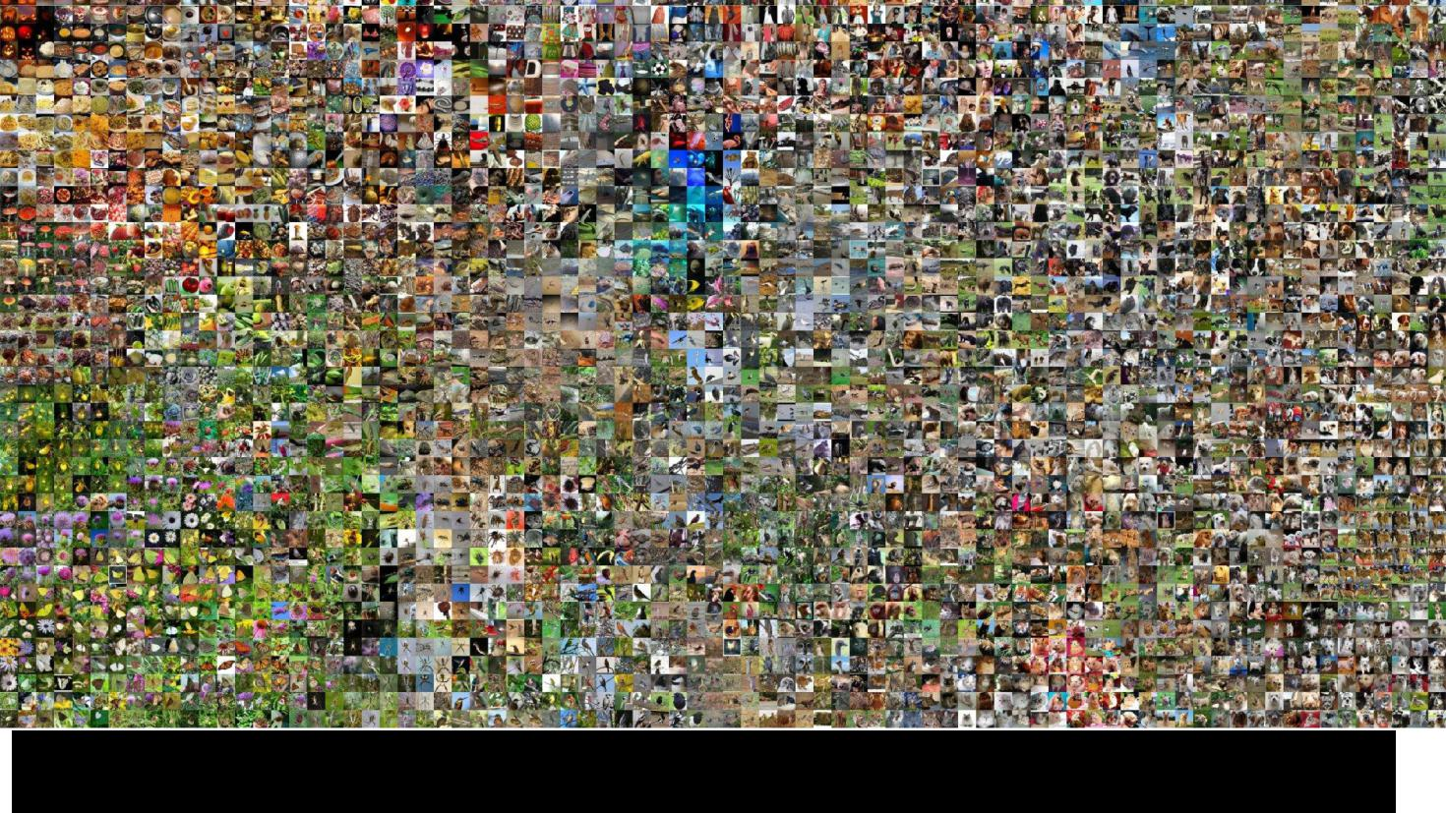

|  |  |  |
| --- | --- | --- |
|  |  |  |
| Fei-Fei Li & Andrej Karpathy & Justin Johnson | Lecture 6 83 | 25 Jan 2016 |
|  |  |  |

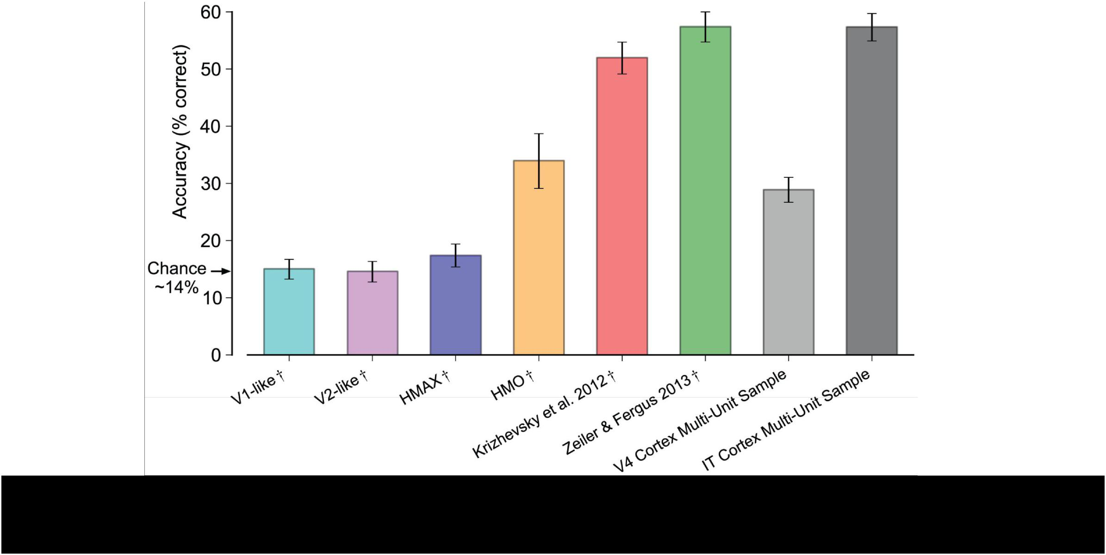

*Deep Neural Networks Rival the Representation of Primate IT Cortex for Core Visual Object Recognition [Cadieu et al., 2014]*



Fei-Fei Li & Andrej Karpathy & Justin Johnson Lecture 6 84 25 Jan 2016

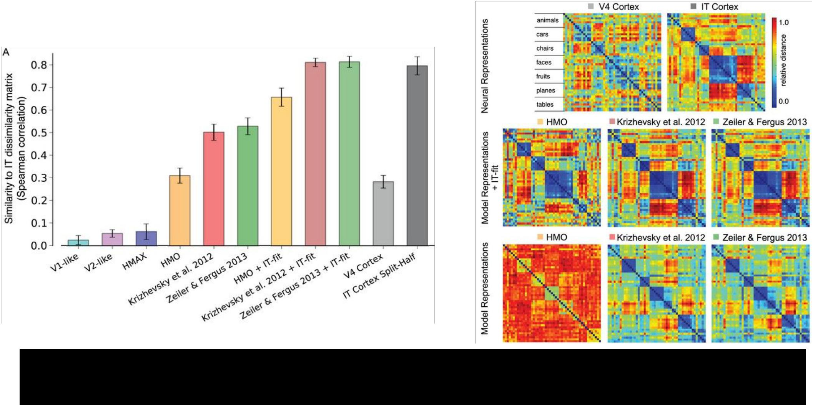

*Deep Neural Networks Rival the Representation of Primate IT Cortex for Core Visual Object Recognition [Cadieu et al., 2014]*



Fei-Fei Li & Andrej Karpathy & Justin Johnson Lecture 6 85 25 Jan 2016



|  |  |  |
| --- | --- | --- |
| Fei-Fei Li & Andrej Karpathy & Justin Johnson | Lecture 6 86 | 25 Jan 2016 |
|  |  |  |